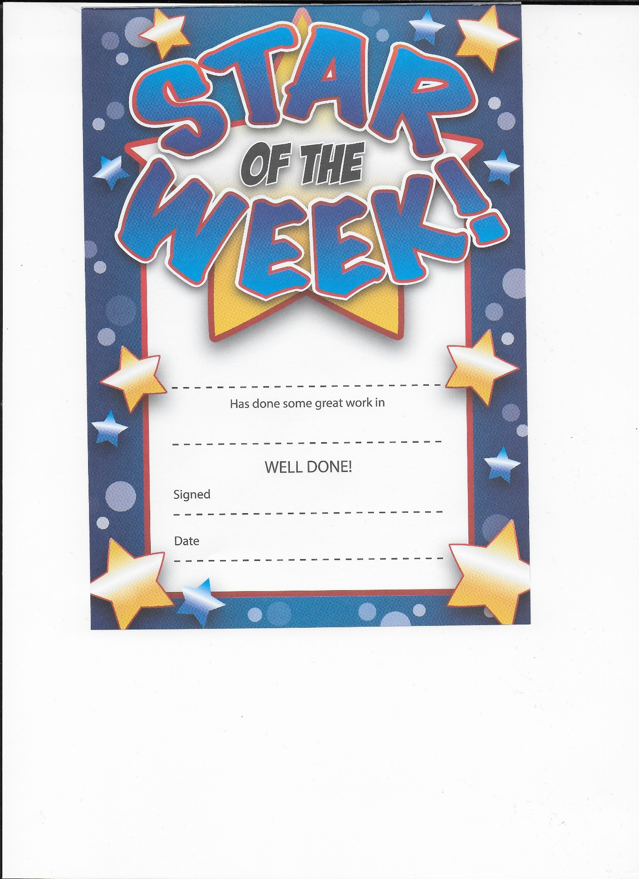

Sam

Writing, well done. You are a superstar!

Miss Hanlon

12th February 2021