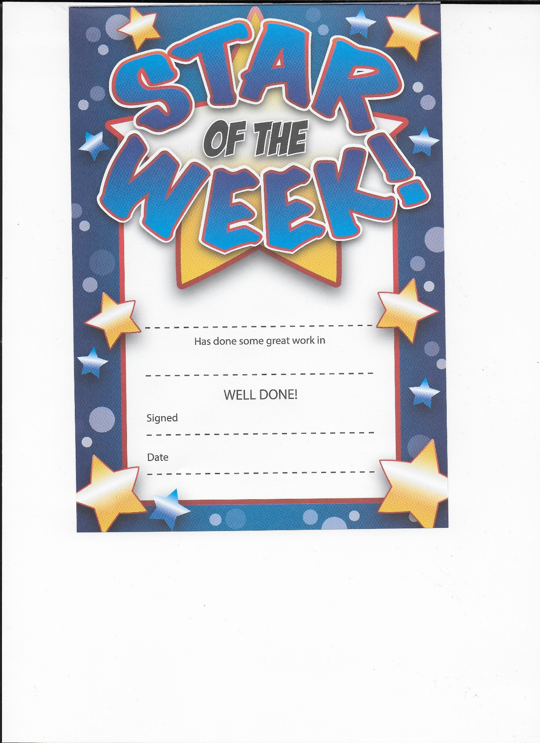

Kian

Positivity & enthusiasm - You are a superstar!

Mrs Barber

12th February 2021

k