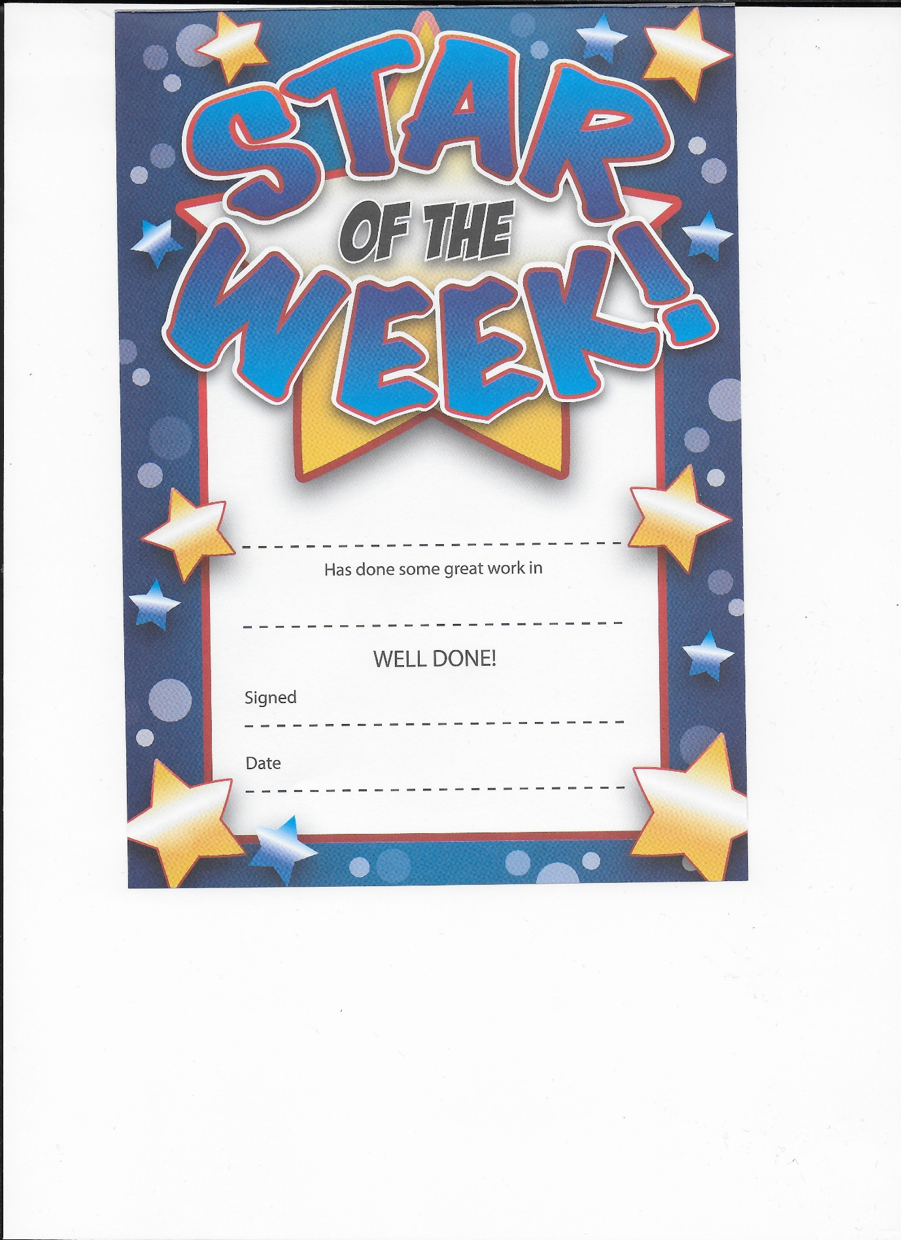

Cole Carvalho- Raggett

Fantastic remote learning

29th January 2021

Mrs Burgess Mrs Washington