Fact file
Name of explorer | Sir Ranulph Twisleton-Wykeham- Fiennes
Early life | Sir Ranulph Fiennes was born in Windsor, Berkshire on 7 March 1944. He was born 4 months after his father died. He went to Sandroyd School in Wiltshire and went to college at Eton College.
Main achievements | Fiennes was awarded a Sultan bravery medal for serving Omani army in 1970. The next medal he was awarded was in 1986 by Loughborough University. Then in 1995, he got a reward from the University of Central England. Next in 2000, he was rewarded by the University of Portsmouth and in 2002 , he was rewarded by Glasgow Caledonian University. Then in 2005, he was rewarded by the University of Sheffield and then in 2007, he was rewarded by the University of Abertay Dundee. He was also rewarded by the University of Plymouth on September 2007 and then he later received the Royal Geographical Society’s Founders Medal. In 1986, he was awarded the polar medal for"outstanding service to British Polar exploration and research."
Portrait of Explorer | 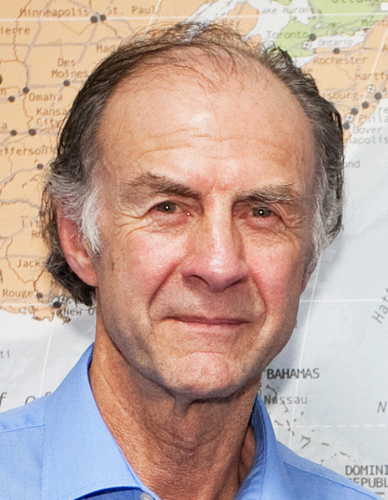
Exploration of the Antarctica | Sir Ranulph Fiennes is famous for being the first person to walk across the North Pole and South Pole on foot. Then at the age of 65 he climbed to the Summit of Mount Everest. He wrote a book and the book was called Cold which was all about how he had survived about the Antarctic and how he had walked across the North Pole and South Pole.

