The Amazing Articles 21st April 1915
ERNEST SHACKLETON AND CREW
HOPE WRECKED!

Article written by Alexander Fisk
In March, Sir Ernest Shackleton and his crew were trapped in the middle of the South Atlantic Ocean with their ship stuck in the ice and left with very little food for them.
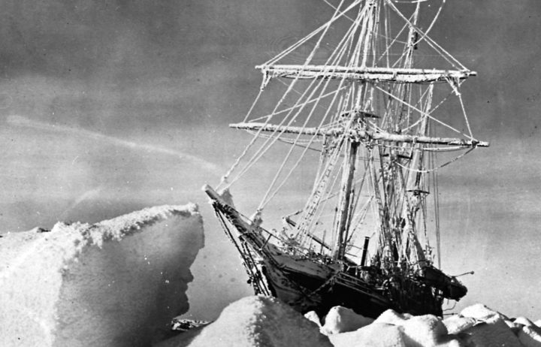
The Endurance stuck on the ice.
This quote is the one Shackleton said before he set off on his cool adventure,

“Life to me is the greatest of all games. The danger lies in treating it as a trivial game, a game to be taken lightly, and a game in which the rules don’t matter much. The rules matter a great deal. The game has to be played fairly or it is no game at all. And even to win the game is not the chief end. The chief end is to win it honourably and splendidly.”

Shackleton and four members of his crew had recovered a lifeboat (The James Caird) and were attempting a journey from Elephant island to South Georgia that led them to safety.

Will they survive the adventure ahead?

We hope and pray they will.
Sir Ernest Shackleton, who had tried to reach the South Pole before, had advertised inviting people to join him on an adventure attempting to reach the South Pole again. Over one hundred people signed up to accompany him but only twenty-seven people were accepted to join the crew. On the 1st August 1914, they set off on the ships (The Endurance and The Nimrod), and the crew was prepared to escort Shackleton on the great exploration to the South Pole.
Several months later, the ships were separated
and The Nimrod was lost to the vast expanse of sky, sea and ice. Along the same course, The Endurance was trapped in the ice. It could move no further in any direction. The crew were in despair but heroically they evacuated the ship, got out their pickaxes and attempted to shatter the ice without damaging the ship. To keep their spirits high, they used their equipment to mark out goals for football and organised tracks for races to keep the dogs healthy. The crew ate their meals inside the ship, due to the freezing weather, and they even had turkey dinners, sausages and mash and beefy meals.
Unfortunately, everything had to be abandoned as the ship capsized due to the ice melting underneath. Fortunately, they managed to rescue the dogs, some food and their tents before the ship surrendered to the ice, but they were left with starvation rations and lack of resources to survive in the icy temperatures.

