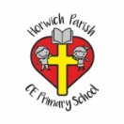 | Street detectives Autumn term 1  Year 2 History
Key vocabulary | Explanation/ definition | Key knowledge
Community | a group of people living in the same place or having a particular characteristic in common.
Feature | a distinctive attribute or aspect of something | Significant historical events, people and places in their own locality.  Changes within living memory.
Industry | processing of raw materials and manufacture of goods in factories.
Compare | estimate, measure, or note the similarity or dissimilarity between. | 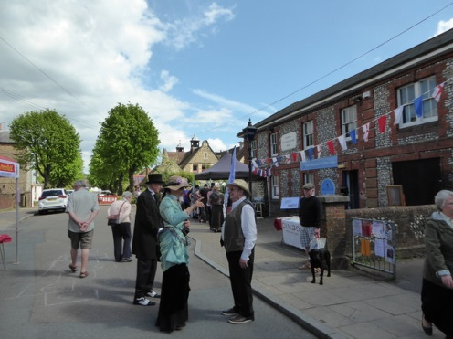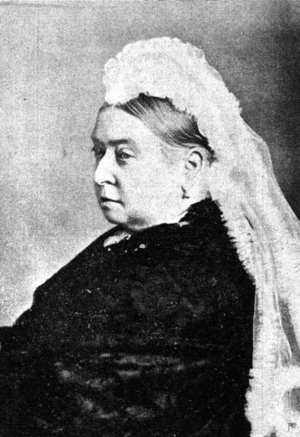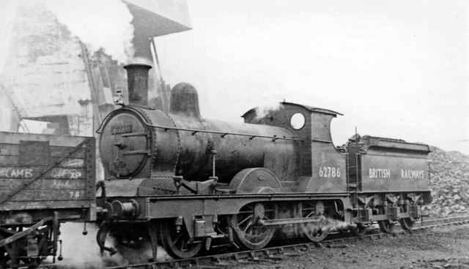  Queen Victoria  Reign - 20 June 1837 – 22 January 1901  Horwich Works was a railway works built in 1886 by the Lancashire and Yorkshire Railway (LYR) in Horwich
Artefact | an object made by a human being, typically one of cultural or historical interest.
Material | the matter from which a thing is or can be made.
Century | - a period of one hundred years.
Property | a thing or things belonging to someone; possessions collectively.
Local | relating or restricted to a particular area.
Change | make or become different. | Famous people and their contributions  Charles Dickens (1812-1870)  Queen Victoria  Isambard Kingdom Brunel. 1806-1859
Victorian | relating to the reign of Queen Victoria (1837-1901)

Towers, tunnels and turrets Autumn 2
Year 2 History
Key vocabulary | Explanation/ definition | Key knowledge
Castle | A castle is a building strengthened against attack.
Battlements | The part of the castle used to fend off attackers. Gaps in the battlements allowed arrows to be launched easily. | Sequence artefacts and photographs  Recognise why people did things, why events happened and what happened as a result  Identify differences between ways of life  Use timeline to order events
Drawbridge | A moveable bridge used to allow or prevent access to a castle.
Moat | A deep ditch that surrounds a castle in order to protect it. It is usually filled with water. | 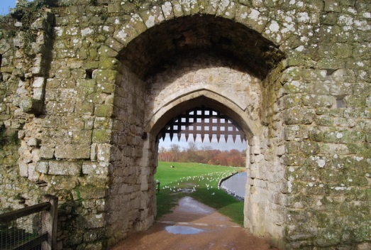  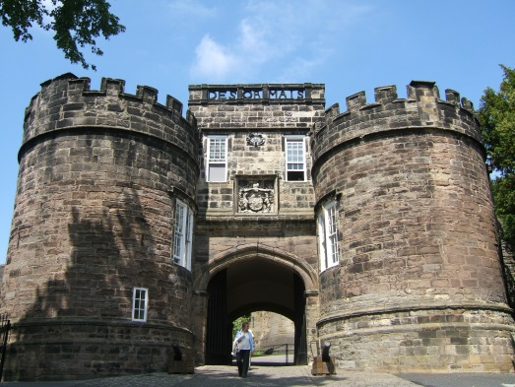  Skipton Castle was first built in 1090.  The portcullis helped to keep enemies out.
Keep | Strong tower in the centre of the castle.
Curtain wall | a fortified wall around a medieval castle
Bailey | - the outer wall of a castle.
Knights | (in the Middle Ages) a mounted soldier in armour.
Lord and lady | People placed in some form of authority.
Structure | The arrangements or parts of something. | Famous people/places  Skipton castle  The Clifford family  Lady Anne Clifford
Chambers | a private room, especially a bedroom.
Pantries | a small room or cupboard in which food, crockery, and cutlery are kept.

Up, up, up and away- Summer Term 1
Year 2 History
Key vocabulary | Explanation/ definition | Flight timeline  1783 1900 2020  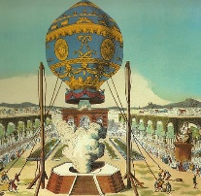  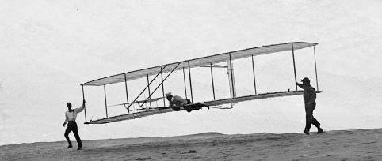  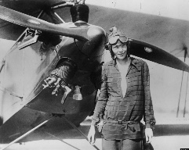  1783 first successful 1903 first successful plane flight 1932 first woman to fly solo  hot air balloon flight across the Atlantic  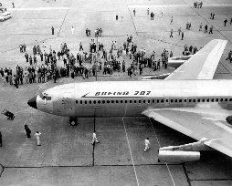  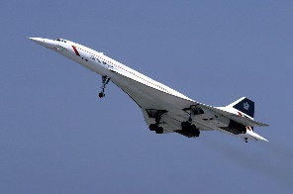  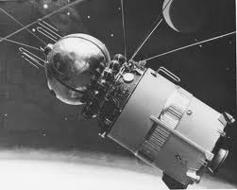  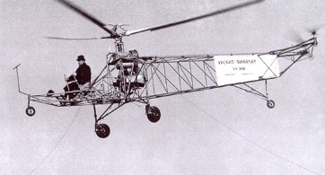  1939 first helicopter flight 1957 first airliner 1961 first flight 1996 Concorde’s first  passenger flight into space flight
aeroplane | a powered flying vehicle with fixed wings and a weight greater than that of the air it displaces.
aviation | the flying or operating of aircraft.
flight | the action or process of flying through the air.
helicopter | a kind of aircraft. Unlike an airplane, a helicopter can fly straight up and down, sideways, or backward. It can also spin around or hover motionless in the air. Helicopters can fly lower than airplanes can, too.
hot air balloon | is the oldest form of flying technology that can successfully carry people.
invention | the act of inventing. a creation (a new device or process) resulting from study and experimentation.
space shuttle | - a rocket-launched spacecraft able to land like an unpowered aircraft, used to make repeated journeys between the earth and space.
timeline | a sequence of related events arranged in chronological order and displayed along a line (usually drawn left to right or top to bottom)
transatlantic | crossing or extending across the Atlantic Ocean
transport | take or carry (people or goods) from one place to another by means of a vehicle, aircraft, or ship. | Famous people and their contributions  The Montgolfier brothers…The Wright brothers…  Amelia Earhart…Leonardo Da Vinci
travel | to get around , move from one place to another

