Design and Technology Year 5 Mechanical system (pulleys or gears) –
Jeep for safari
Project title |  |  | Technical Knowledge and understanding.
Jeep for Safari  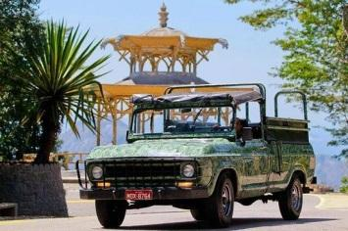 | 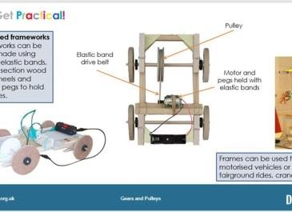  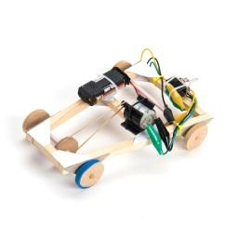 |  | - Understand that mechanical and electrical systems have an input, process and an output.  - Understand how gears and pulleys can be used to speed up, slow down or change the direction of movement.  - Know and use technical vocabulary relevant to the project.
 |  |  | Focused skills
- Using a construction kit, investigate combinations of two different sized pulleys to learn about direction and speed of rotation
- Build a working circuit that incorporates a battery, a motor and a handmade switch, such as a reversing switch. Demonstrate the accurate use of tools and equipment Draw a pictorial representation of the circuit or draw a circuit diagram using correct symbols.
- Develop measuring, marking, cutting, shaping and joining skills
Vocabulary |  |  | Key Learning
pulley  a simple machine that makes lifting something easier | gear  a part of a machine that causes another part to move because of connecting teeth | axle  a bar or shaft on which a wheel or wheels turn. | Prior Learning.  - Experience of axles, axle holders and wheels that are fixed or free moving.  - Basic understanding of electrical circuits  - Experience of cutting and joining techniques  - An understanding of how to strengthen and stiffen structures. | Design  - Generate innovative ideas by carrying out research  - Develop a simple design specification  - Develop and communicate ideas through discussion, annotated drawings, exploded drawings and drawings from different views.
circuit  the closed path followed by an electric current. | functionality  the quality of being suited to a purpose | reinforce  strengthen or support
motor  a machine that causes motion or power. | drive belt  a belt that transmits drive from a motor or engine to a moving part or machine tool. | evaluate  assess | Make  - Produce detailed lists of tools, equipment and materials. Formulate step-by-step plans  - Select from and use a range of tools and equipment to make products that that are accurately assembled and well finished. Work within the constraints of time, resources and cost. | Evaluating  - Compare the final product to the original design specification.  - Test products with intended user and critically evaluate  - Consider the views of others to improve their work.  - Investigate famous manufacturing and engineering companies relevant to the project.

