Key vocabulary
classification | Grouping things based on their characteristics so that they can be identified.
classification key | A series of yes/no questions that help identify or classify things.
environment | The conditions in which a living thing exists. Soil, climate and other living things all count as part of the environment.
habitat | The place where an animal or plant lives.
migrate | The long-distance movement of animals, usually due to a change in the seasons.
hibernate | An animal or plant that spends the winter in a dormant state.
vertebrates | Animals that have a backbone. Fish, amphibians, reptiles, birds and mammals.
invertebrates | Animals that do not have a backbone. Examples are snails, worms, spiders and insects.
© ECM Education Consultants 2019
How can environments change?
Natural changes | This could be caused by flooding, fire, earthquakes etc
Human have an impact on the environment:
Positive impact  This could be:  - setting up a nature reserve  - tree planting  - creating a garden pond. |  | Negative impact  This could be:  - littering  - deforestation  - air pollution  - plastics in the oceans
Living things and their habitats – Year 4
Significant scientists
Jane Goodall  (Born 1934)  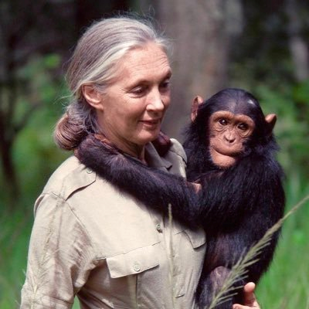 | Jane Goodall is an expert on wild chimpanzees. She is known for her ground breaking discoveries about their behaviour. She has shown us the urgent need to protect chimpanzees from extiction.
Seirian Sumner | Dr Seirian Sumner is an evolutionary biologist and behavioural ecologist. She specialises in social evolution and behaviour in insects (bees, wasps and ants).

Environments can change with the seasons:
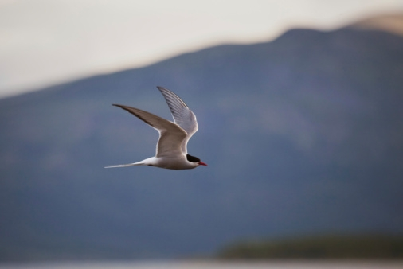
Arctic tern migrates from the Arctic to Antarctica.

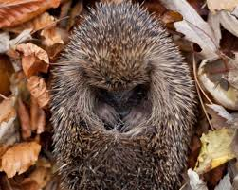
Hedgehogs hibernate in the winter in small, dry, sheltered places, like tree roots.

Classification keys
A key to sort leaves
