Key vocabulary
evolution | The way in which plants and animals have changed over millions of years.
offspring | A person’s child/children or an animal’s young.
inherited | The way a trait or characteristic is passed to offspring from parents.
characteristics | A distinguishing trait, feature or quality.
variation | A change or small difference.
adapted | Animals and plants are adapted to their environment. Their bodies are suited to the way they live.
environment | The conditions in which a living thing exists.
species | A group of closely related organisms that are very similar to each other. We are the human species.
fossil | The naturally preserved remains or traces of animals or plants that lived long ago.

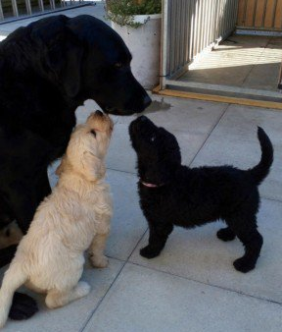
© ECM Education Consultants 2019
Living things produce offspring of the same kind. The offspring are not normally identical to their parents and vary from each other.
Evolution and inheritance – Year 6
Significant scientists
Charles Darwin  (1809-1882)  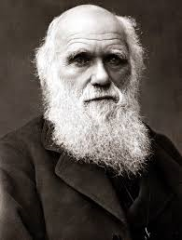 | Charles Robert Darwin was born in Shrewsbury and was an English naturalist and biologist. His scientific theory of evolution by natural selection became the foundation of modern evolutionary studies.
Alfred Wallace  (1823-1913)  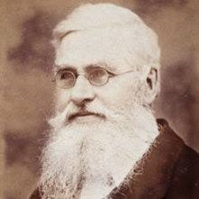 | Alfred Russel Wallace was an explorer, naturalist and anthropologist. He independently proposed the theory of evolution by natural selection. He worked around the world gathering evidence to support his theory.

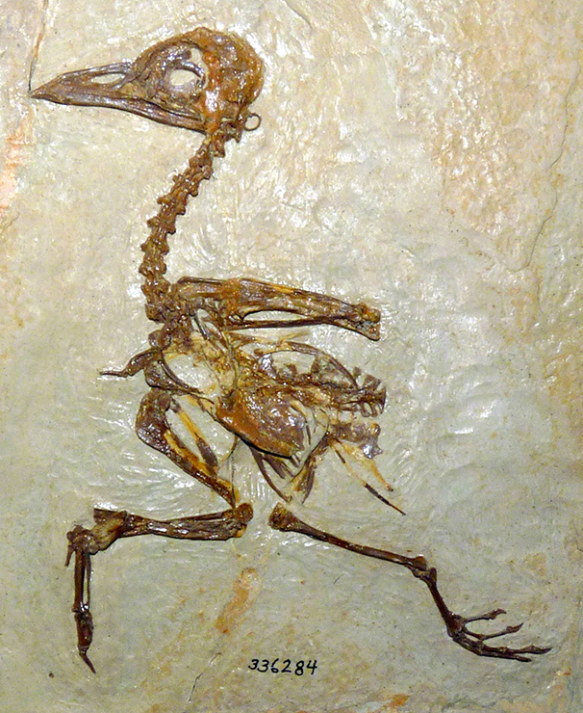
Fossils give us evidence of what lived on the Earth millions of years ago.
By studying fossils, scientists can put together how a plant or animal looked. They can identify what the animal ate, where it lived and how it died.

Adaptation
Plants and animals have characteristics that make them suited to their environment. E.g. camel:
nostrils that can close
long eyelashes
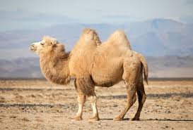
humps to store fat
camouflaged body colour.
thick, rubbery lips
wide feet

Evolution
Adaptation can lead to evolution if the environment changes. Animals and plants with variations that are best suited survive in greater numbers to reproduce and pass their characteristics on to their young. This is natural selection. Over time these inherited characteristics become more dominant within the population.
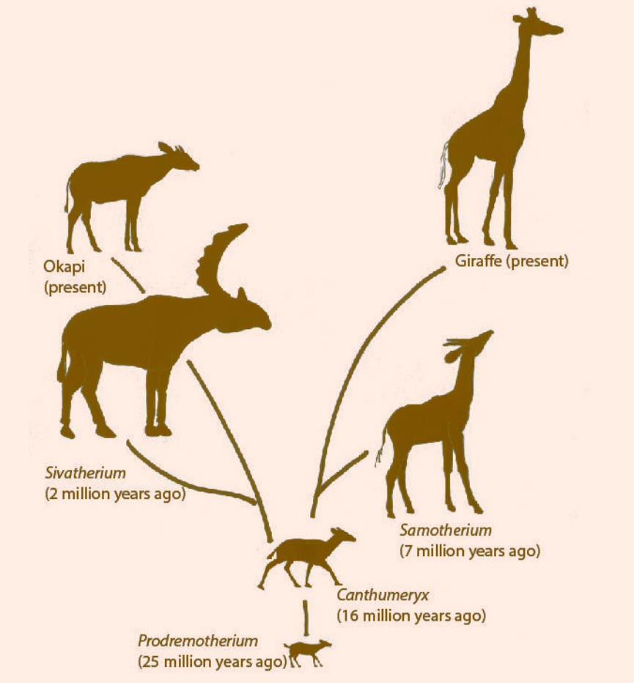
Giraffes have evolved to have a longer neck through natural selection. This means they can reach food on the higher branches of trees.

