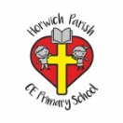 | RE Summer term 1 Year Six  Ideas about God/ Names of God in other faiths
Key vocabulary | Explanation/ definition | Key Knowledge
God | The name God is given to the spirit or being who is worshipped as the creator and ruler of the world, especially by Jews, Christians, and Muslims. | - Bible stories help to deepen our knowledge and understanding of God.  - we (Christians) believe God is three in one, the Trinity.  - God is given many names by Christians and members of non-Christian faiths. These names describe His nature and characteristics,  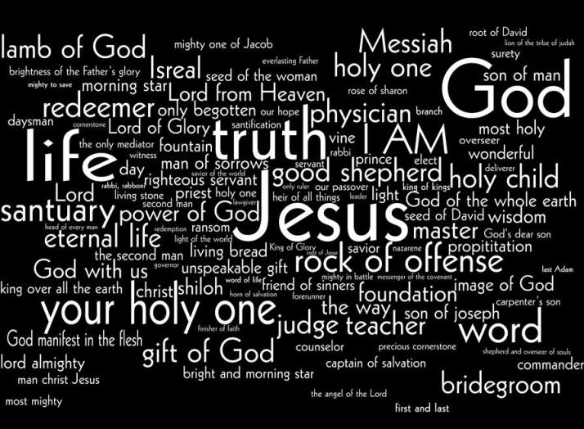  - Bible texts are used to answer questions about the characteristics and nature of God.  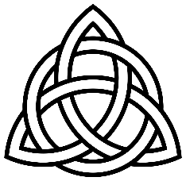  Celtic Trinity knot
Father | paternal protector or provider, the first person in the Trinity
Son | the male offspring of the Father, the second person in the Trinity
Holy Spirit | the spirit of God; the third person of the Trinity
Trinity | In the Christian religion, the Trinity or the Holy Trinity is the union of the Father, the Son, and the Holy Spirit in one God.
Celtic | of an ancient European people who are related to the Irish, Scots, Welsh, and Bretons, or of their language or culture
Allah | Allah is the name of God in Islam.
Brahman | Hindus believe Brahman is the supreme God who controls the universe
Key skills
By the end of this unit, pupils are expected to be able to:

use religious language to show they are developing an understanding of the Trinity.

identify the elements in Christian worship that express Christian beliefs about God.

ask big questions and express their own views.

