Design and Technology Year 6 Hola Mexico!
Food – Mexican dishes
Project objective |  |  |  | Technical Knowledge and understanding.
Design, make and evaluate Mexican food. | 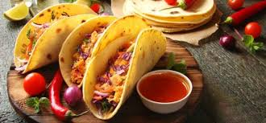  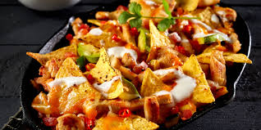 |  |  | Know how to use utensils and equipment including heat sources to prepare and cook food.  Understand about seasonality in relation to food products and the source of different food products.  Know and use relevant technical and sensory vocabulary.
 |  |  |  | Focused skills
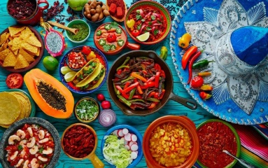 |  |  |  | Demonstrate how to measure out, cut, shape and combine e.g. knead, beat, rub and mix ingredients.  Demonstrate how to use appropriate utensils and equipment that the children may use safely and hygienically.  Techniques could be practised following a basic recipe to prepare and cook a savoury food product.  Ask questions about which ingredients could be changed or added in a basic recipe such as types of flour, seeds, garlic, vegetables. Consider texture, taste, appearance and smell.  When using a basic dough recipe, explore making different shapes to change the appearance of the food product e.g. Which shape is most appealing and why?
Vocabulary |  |  |  | Key Learning
Preparing process |  |  | Cooking process | Prior Learning  Have knowledge and understanding about food hygiene, nutrition, healthy eating and a varied diet.  Be able to use appropriate equipment and utensils, and apply a range of techniques for measuring out, preparing and combining ingredients. | Designing  Generate ideas through research and discussion with peers and adults to develop a design brief and criteria for a design specification.  Explore a range of initial ideas, and make design decisions to develop a final product linked to user and purpose.  Use words, sketches and information and communication technology as appropriate to develop and communicate ideas.
-Slicing: cutting food using a knife.  -Mixing: to blend ingredients together, using a spoon, blender, or whisk.  -Weighing/measuring: to get the right amount of an ingredient, using scales, table/teaspoons  Grating: to peel a layer off something (like carrots or cheese) using a peeler or grater.  -Serving: making food look nice on the plate.  -Adding/ substituting: changing the taste of food by adding or replacing ingredients. |  | -Baking: to cook food in a heated oven.  -Boiling: to cook food in boiling (100°C ) water.  -Frying: to cook food in a pan of heated oil.  -Grilling: to cook food by putting it under a hot grill (like a radiator in a cooker).  -Griddling: to cook on a flat iron plate called a griddle.  -Steaming: to cook using steam, normally from boiled water.  -Poaching: to cook by simmering in a small amount of liquid.
 |  |  |  | Making  Write a step-by-step recipe, including a list of ingredients, equipment and utensils  Select and use appropriate utensils and equipment accurately to measure and combine appropriate ingredients.  Make, decorate and present the food product appropriately for the intended user and purpose. | Evaluating  Carry out sensory evaluations of a range of relevant products and ingredients. Record the evaluations using e.g. tables/graphs/charts.  Evaluate the final product with reference back to the design brief and design specification, taking into account the views of others.  Understand how key chefs have influenced eating habits to promote varied and healthy diets.

