Ppppkhgdedsa

**Maths**

Place value

Rounding

Adding and subtracting

Multi-step problems



**P.E.**

Invasion games

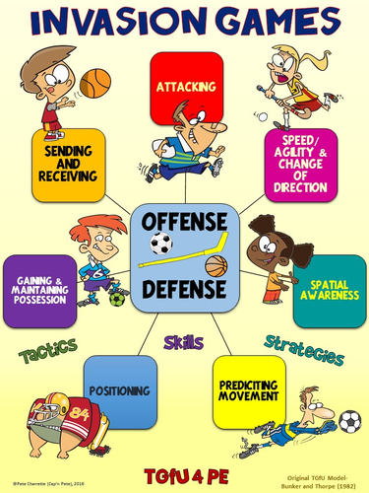

**Art/DT**

We will be exploring techniques to draw facial features and researching the artist Frida Kahlo.

We will be learning how to cook some Mexican foods.

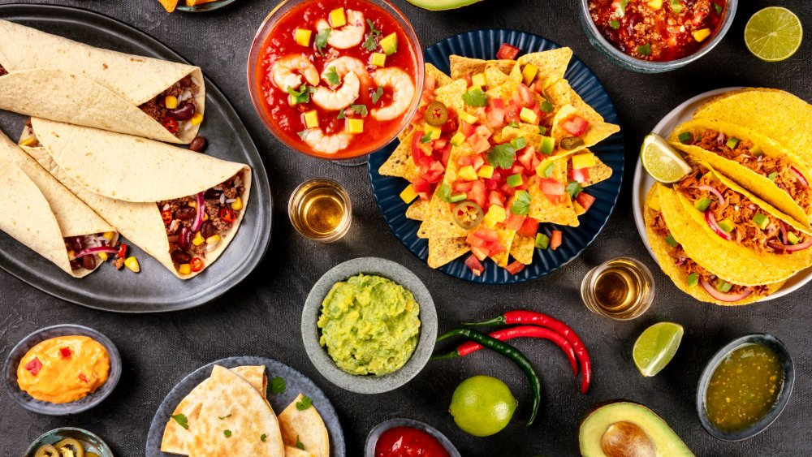

**Literacy**

We will be reading the story ‘Holes’ by Louis Sachar. Our literacy lessons will be based on the book .Also, we will be examining non- fiction books about the Mayan civilisation. Over the project we will be writing: diary entries, reports, and a narrative.

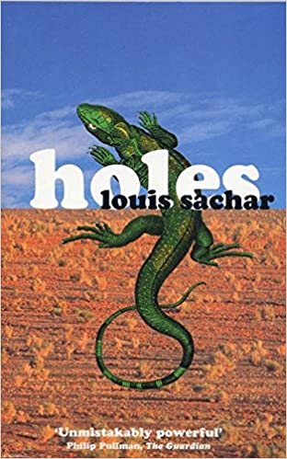

Genera Information

**Weekly** : Two activities based on maths, reading and grammar skills

**Spellings weekly**- in Pirate books

**Additional spellings:** common words to learn over the half term at home and tested at the end of each half term.

**Reading book of own choice:** parent/ carer to sign **three times** each week in the ***Inspiring Readers booklet*** to gain ‘Golden time’ at the end of the week.

**Homework to be given out on** :Friday

**Returned by**: the following Thursday

**Spelling test on**: Friday and new spellings given on the same day

Music

‘Happy’ is a unit of work based around Happy by Pharrell Williams – a pop song with a Soul influence about being happy.

**Science**

The focus lessons will be ‘Living things and their habitats’ - this will involve learning about the classifications of animals, the scientist Carl Linnaeus and all about micro organisms

**Religious Education**

Life as a journey and pilgrimage – we will create maps of our lives and research places for pilgrimage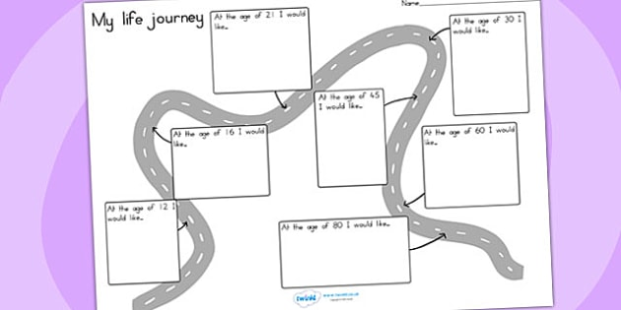

PSHCE

Keeping and staying safe

**I.C.T**

Online Safety Purple mash

History

As part of our history lessons, we will be researching the Mayan civilisation including the food, culture and beliefs

. 