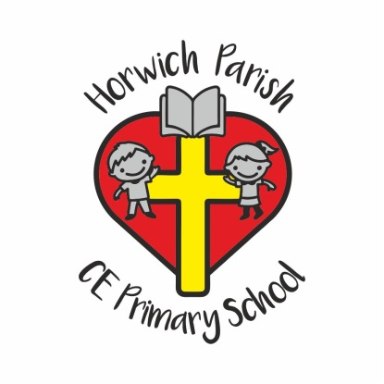 | Horwich Parish C.E. Primary School  Church Street  Horwich  Bolton  BL6 6AA  Head Teacher: Mrs D Mills  Telephone: 01204 333147  Email: head@horwichparish.net

Pupil Leave of Absence Request Form – Medical Appointment

Pupils attend school for a maximum of 190 days each academic year. Full attendance is vital for your child’s educational progress. The Local Authority expects all parents\carers to ensure that their children attend school whenever possible. Absences due to holidays taken during school time could hinder their academic attainment and are therefore classed as unauthorised in line with the Local Authority guidelines.

If you wish to apply for your child to be absent from school for a medical appointment, please complete this form and return it to school as soon as possible.

Please complete all sections.

Child’s Name: ………………………………………………………………………………………….. Class: ……………………………………………………

Reason for Absence: …………………………………………………………………………………………………………………………………………………..

Date of Appointment: …………………………………………………………………………. Time of Appointment: ………………………………

Time to be collected from school: ……………………………………………….. am/pm

What time will your child return to school (if applicable): ………………………………………………………………………………………….

If your child is on school meals, will they require a lunch?: ………………………………………………………………………………………..

*Signature: …………………………………………………………………… Print: ………………………………………………………………………………

*(Please note that this form must be signed by someone who has parental responsibility as defined by the Children Act 1989).

