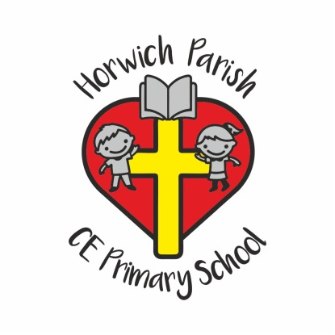 | Horwich Parish C.E. Primary School  Church Street  Horwich  Bolton  BL6 6AA  Head Teacher: Mrs D Mills  Telephone: 01204 333147  Email: head@horwichparish.net
Pupil Leave of Absence Request Form

Pupils attend school for a maximum of 190 days each academic year. Full attendance is vital for your child’s educational progress. The Local Authority expects all parents\carers to ensure that their children attend school whenever possible. Absences due to holidays taken during school time could hinder their academic attainment and are therefore classed as unauthorised in line with the Local Authority guidelines. School has the right to exercise the school policy to issue penalty notices to those parents removing their child from school for 5 days or more during term time.

If you still wish to apply for your child to be absent from school, please complete this form and return it to school at least two weeks before the intended departure. The Headteacher will respond within one week.

Parents Section.

Child’s Name: ………………………………………………………………………………………….. Class: ……………………………………………………

Address (including postcode): …………………………………………………………………………………………………………………………………….

…………………………………………………………………………………………………………………………………………………………………………………

Reason for absence: …………………………………………………………………………………………………………………………………………………..

First date of absence: …………………………………………… Date back in school: ……………………………………………………………

Total number of days requested:

*Signature: …………………………………………………………………… Print: ………………………………………………………………………………

*(Please note that this form must be signed by someone who has parental responsibility as defined by the Children Act 1989).

For school use only Horwich CofE School

To Parent\Carer of: ……………………………………………………………..…… Class: …………………………………………………………………….

Number of days requested: ……………………… Dates: …………………………………. to …………………………………………………………

Number of days requested previously: ………………………… Number of days unauthorised: ………………………………………….

Reason why request authorised/unauthorised: ………………………………………………………………………………………………………….

