RE Spring term 2 Year Five
Why do Christians believe that Easter is a celebration of Victory?
Key vocabulary | Explanation/ definition | Key Knowledge
Victory | The winning of a battle or contest. | - Christians believe that Christ’s resurrection is a victory over death and talk about it with understanding.  - Christians believe that the death and resurrection of Jesus restored the relationship between God and people.  - The Easter story is at the very heart of Christian belief.  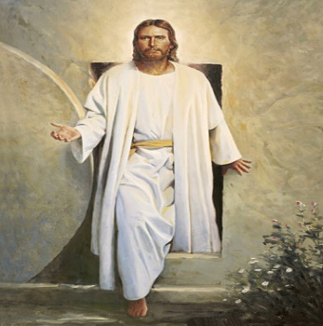  Jesus’ resurrection The Lion the Witch and the Wardrobe:  Aslan sacrifices his life for Edmund
Triumph | Happiness caused by victory or success.
Resurrection | Rising again especially from the dead.
Sacrifice | Giving up of something valuable or important to help someone or something else.
Salvation | Fact or state of being saved from harm or the consequences of sin.
Redeemer | A person who redeems someone or something.
Redeems | To free from sin.
Key skills
By the end of this unit, pupils are expected to be able to:
- Retell the Easter story in detail and talk with understanding about the Christian belief that Jesus died and rose victoriously and what it means to Christians.
- Talk about and describe feelings in relation to situations of victory; make links between people’s values and commitments and their attitudes and behaviour with regard to situations of victory.
- Describe the impact of belief in the Easter story on a person’s life.

