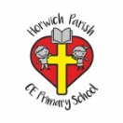 | RE Autumn term 2 Year Four  Christmas. Exploring the symbolism of light
Key vocabulary | Explanation/ definition | Key Knowledge
Jesus | The son of God. | - Hanukkah is an important Jewish festival of light.  - Light is used as a metaphor to describe Jesus and his impact on the world.  - The light of Jesus brings hope in dark places.  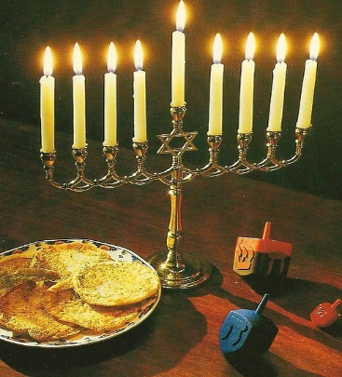  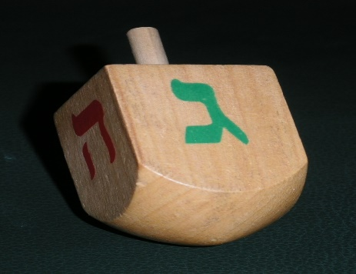
Light | The natural agent that stimulates sight and makes things visible.
Candles | A stick of wax enclosing a wick, which is burned to produce light.
Christingle  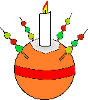 | A candle lit festive celebration held in churches.  Consists of:  - An orange that represents the world.  - The red ribbon (or tape) symbolises the love and blood of Christ.  - The sweets and dried fruit represent all of Gods creations.  - The lit candle represents Jesus’ light in the world, bringing hope to people living in darkness.
Light of the World | Jesus gives life, just as the sun gives life to the world. He also leads his followers through the dark and difficult times of our lives, providing guidance and hope.
Saviour | Person who rescues you.
Incarnation | A living being embodying a deity (god or goddess) or spirit
Dreidel | A four-sided top bearing the Hebrew letters nun, gimel, he, and shin, used chiefly in a children’s game traditionally played on the Jewish festival of Hanukkah.
Hanukkah | A Jewish holiday which celebrates the victory of the Maccabees over the larger Assyrian army. It also celebrates a miracle that happened during this time, where just a day’s supply of oil allowed the menorah in the rededicated Temple in Jerusalem to remain lit for eight days.
Hannukiah

Jerusalem | A holy city for Jews, Christians and Muslims; the capital of the ancient kingdom of Judah and of the modern state of Israel.
Temple | a building used for the worship of a god or gods, especially in the Buddhist, Jewish, Mormon, and Hindu religions, and in ancient Greek and Roman times
Key skills
By the end of this unit, pupils are expected to be able to:
- Talk with understanding about the ways in which Jesus’ followers bring his light into the world.
- Create light metaphors for Jesus that show understanding of Jesus’ actions and divinity.
- Ask important and relevant questions about religious experiences and beliefs.
- Talk with understanding about the symbolism of Jesus as alight

