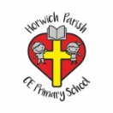 | RE Spring term 2 Year Four  Why do Christians call the day Jesus died Good Friday?
Key vocabulary | Explanation/ definition |  | Key Knowledge
Gospel | Good news. Jesus’ life embodied what it is like to o=be one of the people of God, what it means to live in relationship with God. |  | Pupils will know that  - Christians see Holy Week as the culmination of Jesus’ earthly life, leading to his death and resurrection.  - The various events of Holy Week, such as the Last Supper, were important in showing the disciples what Jesus came to earth to do.  - Christians today trust that Jesus really did rise from the dead, and so is still alive today.  - Christians remember and celebrate Jesus’ last week, death and resurrection.  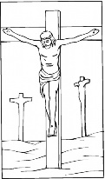  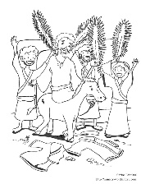  Palm Sunday Good Friday Easter Sunday
Incarnation | Jesus is God in the flesh, and that, in Jesus, God came to live among humans.
Creation | The universe and human life are God’s good creation. Humans are made in the image of God.
Fall | A separation between God and humans.
Salvation |  | Jesus’ death and resurrection offer the rescue or salvation of humans. Through Jesus, sin is dealt with, forgiveness offered and the relationship between God and humans is restored.
Holy Week |  | the week before Easter Sunday, when Christians remember the events leading up to the death and resurrection of Jesus.
Key skills
By the end of this unit, pupils are expected to be able to:
- Order Creation and Fall, Incarnation, Gospel and Salvation within a timeline of the Bible’s ‘Big Story’
- Offer suggestions for what the texts about the entry into Jerusalem, and the death and resurrection of Jesus might mean.
- Give examples of what the texts studied mean to some Christians.
- Make simple links between the Gospel texts and how Christians mark the Easter events in their church communities.
- Describe how Christians show their beliefs about Palm Sunday, Good Friday and Easter Sunday in worship.
- Make links between some of the stories and teachings in the Bible and life in the world today, expressing some ideas of their own clearly.

