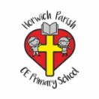 | RE Summer term 1 Year Three  Which rules should we follow? Does everyone follow the same rules?
Key vocabulary | Explanation/ definition | Key Knowledge
Rules | an accepted principle or instruction that states the way things are or should be done, and tells you what you are allowed or are not allowed to do | - The Old Testament contains the stories of the people of God.  - Moses rescues the people of God from Egypt and brings the ten commandments down from Mount Sinai.  - Other faiths have rules to follow that have been given to them a long time ago.  - Christians try to live out the commandments given by God and Jesus.  - The commandments are the foundation of Christian and Jewish societies.  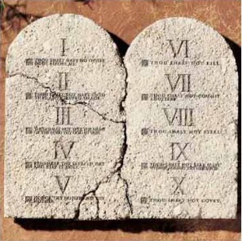  Mount Sinai The Ten Commandments  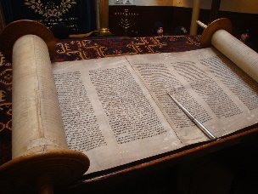  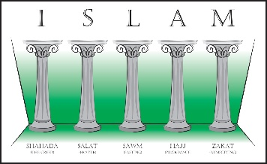  The Five Pillars of Islam The Torah
Laws | a rule, usually made by a government, that is used to order the way in which a society behaves
Moses | the Hebrew prophet who led the Israelites out of Egypt and delivered the Law during their years of wandering in the wilderness.
Commandment | an order, especially one of the Ten Commandments
Mount Sinai | a mountain peak in the southern Sinai Peninsula (7,500 feet high); it is believed to be the peak on which Moses received the Ten Commandments.
Covenant | a formal agreement or promise between two or more people
Old Testament | The Old Testament is the first part of the Bible. It deals especially with the relationship between God and the Jewish people.
New Testament | The New Testament is the part of the Bible that deals with the life and teachings of Jesus Christ and with Christianity in the early Church.
The five pillars of Islam | the five duties expected of every Muslim: profession of the faith in a prescribed form, observance of ritual prayer, giving alms to the poor, fasting during the month of Ramadan, and performing a pilgrimage to Mecca
The Torah | the holy writings of the Jewish religion, esp. the first five books of the Old Testament
Key skills
By the end of this unit, pupils are expected to be able to:
talk about the story of Moses and the impact of the ten commandments.
name some of the rules followed by people of other faiths.
describe ways in which Christians live out Jesus command to love one another.
make links between beliefs and behaviour.
talk, with understanding, about rules from faiths other than Christianity.
understand the effects of rules and ask good questions about religious rules.
express their own ideas about rules.

