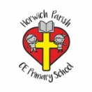 | RE Spring term 2 Year Two  Easter: How do symbols help us to understand the story?
Key vocabulary | Explanation/ definition | Key Knowledge
Cross | An emblem of Christianity. A wooden structure used to execute Jesus. | - There are different objects and symbols used to help explain and understand the meaning of Easter.  - The Easter story is central to Christian belief.  - The death and resurrection of Jesus is part of God’s salvation plan.  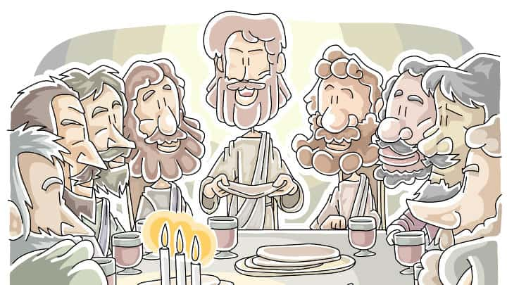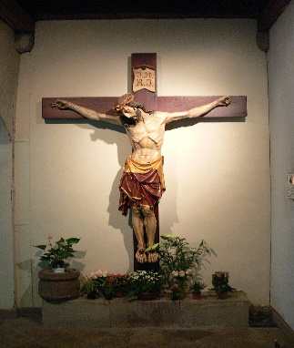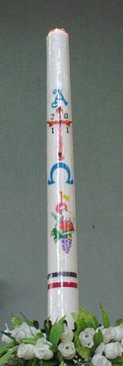
Crucifix | A cross with the figure of Jesus on it.
Paschal candle | A large candle blessed and lit on Holy Saturday and placed by the alter until Pentecost.
Resurrection | Rising again: the coming back to life of Jesus Christ three days after his death.
Last Supper | - The supper eaten by Jesus and his disciples on the night before Jesus’ death.
Eucharist | Religious ceremony in which Christians remember and celebrate Christ’s last meal with his disciples.
Symbol | Shape, design or idea that is used to represent something.
Light of the World | Jesus, the light of the world, shines in the darkness and the darkness cannot overcome him
Sacrifice | Giving up something valuable or important to help someone or something else.
Celebration | The festivities engaged in to celebrate something.
Key skills
By the end of this unit, pupils are expected to be able to:
- Identify and name some of the symbols of Easter.
- Retell the Easter story
- Talk about their own experiences of Easter celebrations.
- Use religious vocabulary to simply describe what the symbols of Easter mean.
- Describe briefly why Christian people celebrate Easter.
- Explain what they think to be the most important thing about Easter.

