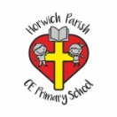 | RE Autumn term 2 Year Two  Christmas. Why was the birth of Jesus such good news?
Key vocabulary | Explanation/ definition | Key Knowledge
Good news | News of something that is of benefit to oneself, one’s friends and one’s community. | - We believe that the birth of Jesus is good news.  - Angels brought the news to Zachariah, Mary and the shepherds.  - We believe that Jesus is the saviour of the world.  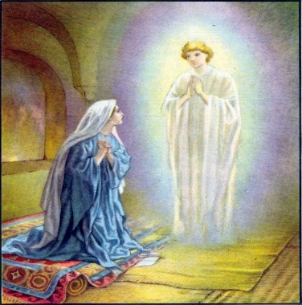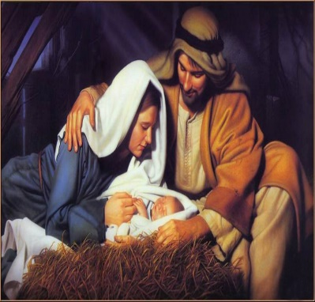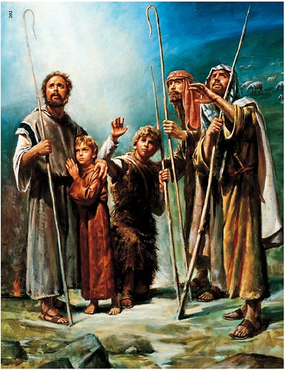
Elizabeth | A relative of Mary (the mother of Jesus), the wife of Zechariah and the mother of John the Baptist.
Zechariah | The husband of Elizabeth and father of John the Baptist.
Jesus | The son of God.
Mary | - The mother of Jesus and wife of Joseph.
Angel Gabriel | The messenger who was entrusted to deliver several important messages on God’s behalf.
Joseph | Jesus’ father on earth and the husband of Mary.
Shepherds | A group of people who look after sheep.
Bethlehem | A town near Jerusalem. The birthplace of Jesus.
Key skills
By the end of this unit, pupils are expected to be able to:
- Ask good questions about the Christmas story.
- Tell you all about what happened to Zachariah.
- Tell you the Christmas story.
- Talk about the message of the angels.
- Describe the different ways artists portray angels
- Talk about the ways we shar the good news at Christmas time.

