What did the Romans do for us? – Spring Term 1
Year 4 History
Key vocabulary | Explanation/definition | Key knowledge | Key people and places
Amphitheatre | A place where Romans went to watch animals and people fighting | The rise and spread of the Roman Empire from 800BC – AD305 (see timeline below). | Julius Caesar – Roman dictator and military general.
Aqueduct | A system of pipes and channels which brings clean water into towns | Roads created by the Romans that are important to us today incl. Fosse Way, Watling Street and Dere Street. | Augustus – first emperor of the Roman empire.
Barbarian | A person who lived outside the Roman Empire, seen as having a violent nature. | Boudicca’s leadership and the rebellion of the Celts. | Rome – capital city of modern Italy.
Chariot | Cart with two wheels pulled by horses. Romans raced chariots, and Celtic warriors rode into battle on them. | The building and preservation of Hadrian’s wall to secure the Roman Empire. | Hadrian’s wall.
Forum | Open space in the middle of a town for markets and meeting people (like a market square) | Roman Gods and Goddesses – male & female couple structure and belief system. | 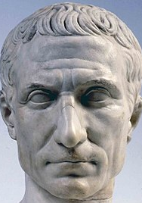
Gladiator | A slave trained to fight other gladiators or animals in amphitheatres. | Roman Baths – a place for socialising and leisure. Sites still preserved to visit today.
Hypocaust | Roman central heating - It works by hot air flowing through gaps between walls and flooring. | The placement and abundance of Roman ruins and the evidence they leave to inform us of life in the Roman empire.
Jupiter | The chief Roman god, equivalent to the Greek god Zeus. He was also the god of thunder and is often seen with thunderbolts in his hand. | 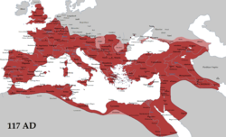
Legion | A military unit recruited from Roman citizens and usually around 5000 men in strength.
Strigil | A metal object used in Baths to scrape sweat, dirt and excess oil off
Stylus | A metal pen for scratching words into wax on wooden tablets.
Villa | A large house in the country. Some villas were farmhouses and some were like palaces.

Time line of events: Roman Invasions:
800BC | 237BC | 133BC | 44BC | AD79 | AD117 | AD305 | Spread of the Roman Empire.

