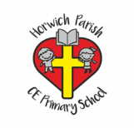 Art Knowledge Organiser Year 6 Drawing WW2 Project
Skills | vocabulary | Artists
Observe and use a variety of techniques to show the effect of light on objects and people e.g. use rubbers to lighten, use pencil to show tone, use tones of the same colour.  Use a variety of techniques to interpret the texture of a surface e.g. mark making, different textured paint.  Produce increasingly accurate drawings of people.  Produce increasingly detailed preparatory sketches for painting and other work.  Work on a variety of scales and collaboratively.  Independently selects materials and techniques to use to create a specific outcome. | Hatching (hachure in French) is an artistic technique used to create tonal or shading effects by drawing (or painting or scribing) closely spaced parallel lines  Stippling is a drawing technique in which areas of light and shadow are created using nothing but dots. The basic idea is simple: For darker areas, you apply a greater number of dots and keep them close together.  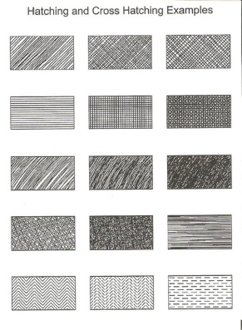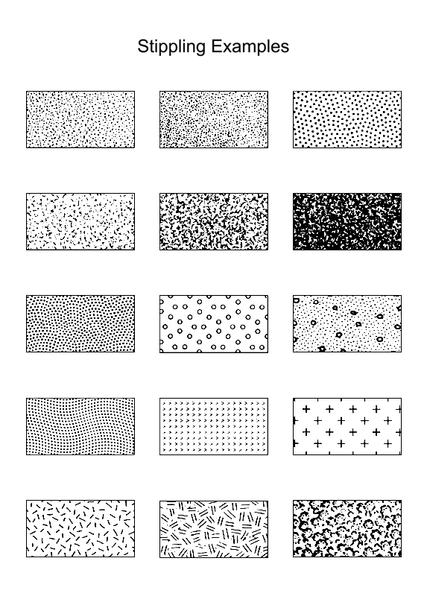 | 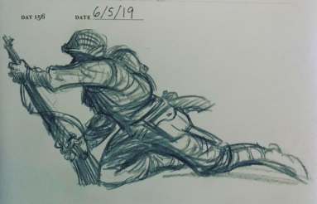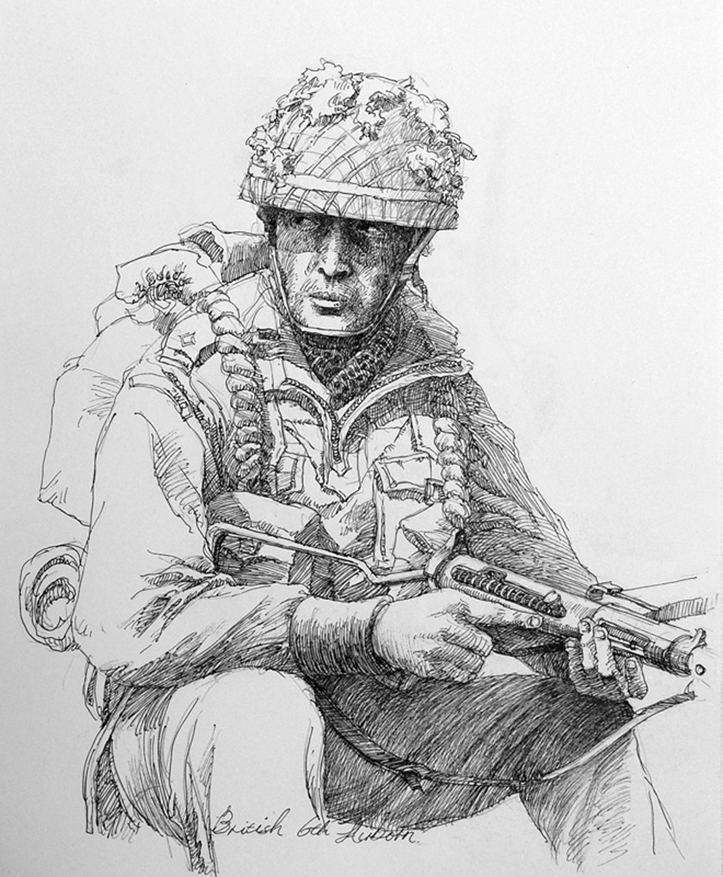  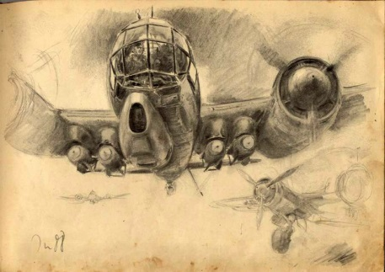  Aric Salyer (Rickman1993)  Hans Liska (1907-1984)

