Art Knowledge Organiser Year 6 Colour Hola Mexico Project
Skills | vocabulary | Artist
Controlling and experimenting particular qualities of tone, shades, hue and mood.  Considering colour for purposes.  Use colour to express moods and feelings.  Explore the texture of paint - very wet and thin or thick and heavy - add PVA to the paint.  Encourage individual identification of suitable equipment for a particular purpose e.g. size of paintbrush or paper needed.  Consider artists use of colour and application of it. | Primary colours:red, yellow and blue  Secondary colours: green , purple and orange  Intensity: the brightness or dullness of a colour.  Monochromatic: a single color and it's tints and shades  Background:an area within a composition that appears further away from the viewer. Objects appear smaller with less detail.  Middle ground: part of a composition that appear between the foreground and back ground Foreground: in a scene or artwork , the part that seems closest to you. Objects appear larger and more detailed.  Spectrum: all the colours in the colour wheel  Palette : a series of colours that you paint with  Watercolour: a water soluble paint with transparent properties | Frida was a Mexican painter known for her many portraits, self-portraits, and works inspired by the nature and artifacts of Mexico. Inspired by the country's popular culture, she employed a naïve folk art style to explore questions of identity, gender, class, and race in Mexican society  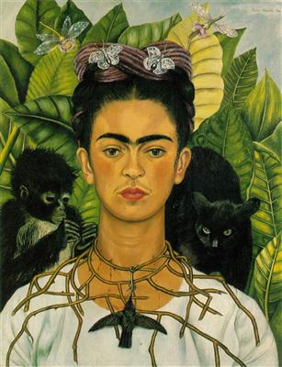  Kahlo painted about seventy self-portraits. The self-portraits demonstrate in her face her feelings of love, loss and passion for those whom she loved.

