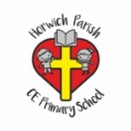 | Topic Name– Spring Term 2  Year 3 Art ‘James Naughton’
Key vocabulary | Explanation/ definition | 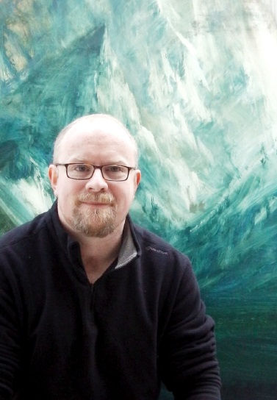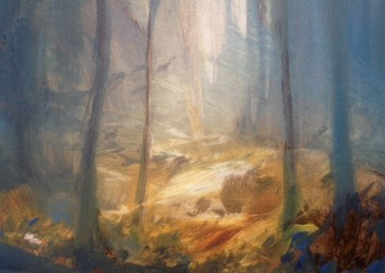  James has been a professional Artist since 1998. Producing oil paintings from Bolton studio (UK) he has created a unique vision of Landscape painting. He has established his reputation through a consistent determination to make art. Trusting instincts which result in emotive experiences for him and the viewer.  His work emerges from three preoccupations, light, landscape and the nature of paint, these combine to result in paintings that link tradition and a modern visual experience. http://jamesnaughton.com/
Oil Paintings | A picture painted with oil paint
Oil Paint | A thick paint made with ground pigment and a drying oil such as linseed oil, used chiefly by artists.
Seascapes | A view of an expanse of sea.
Landscape Paintings | A painting representing a view of the countryside.
Monochrome | Picture in black and white or varying tones of only one colour.
Inspiration | Being mentally stimulated to feel something or do something.
development | The process of creating something.
Crafts | An activity involving skill in making things by hand.
Art Gallery | A room or building which displays works of art.
Ar2/1.2 to improve their mastery of art and design techniques, including drawing,
painting and sculpture with a range of materials

Children can:
a use varied brush techniques to create shapes, textures, patterns and lines;
b mix colours effectively using the correct language, e.g. tint, shade, primary and secondary;
c create different textures and effects with paint;
d use key vocabulary to demonstrate knowledge and understanding in this strand: colour, foreground, middle ground, background, abstract, emotion, warm, blend, mix, line, tone, fresco.

