Street Detectives – Autumn 1
Year 2 Geography
Key vocabulary | Explanation/ definition | Key knowledge
fieldwork | Practical work conducted by a researcher in the natural environment, rather than in a laboratory or office. | Use world maps, atlases and globes to identify the United Kingdom and its countries, as well as the countries, continents and oceans studied at this key stage.
diagram | A simplified drawing showing the appearance, structure, or workings of something; a schematic representation. | Use aerial photographs and plan perspectives to recognise landmarks and basic human and physical features; devise a simple map; and use and construct basic symbols in a key.
symbol | a sign, shape, or object that is used to represent something else | 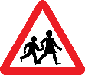
human and physical features | Human features – something that is built by humans and would not have existed without humans – house, city, road, canal  Physical features – Earth’s natural features such as mountains, rivers, deserts, oceans | 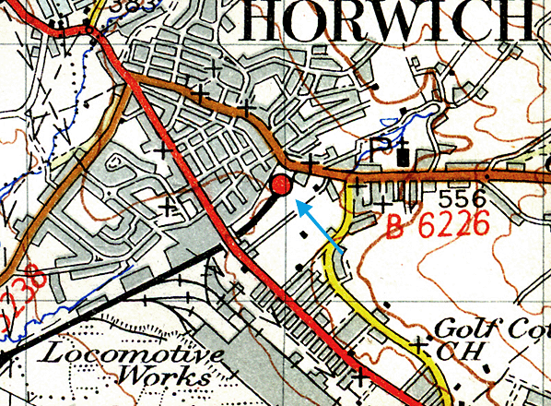  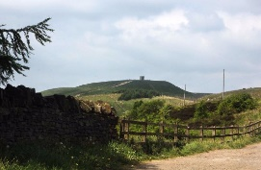  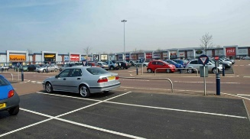  Locate human and physical features on a map or aerial photographs. tp://www.disuse d-statior
hamlet | a small settlement, generally one smaller than a village, without a church. | 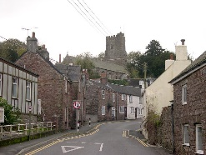  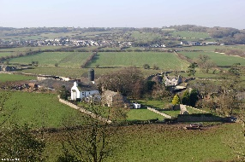  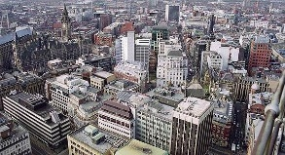  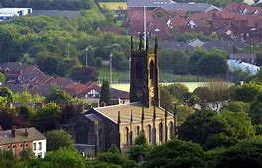
village | a group of houses and other buildings that is smaller than a town, usually in the countryside
town | a place where people live and work, containing many houses, shops, places of work, places of entertainment, etc., and usually larger than a village but smaller than a city
city | A large town with a cathedral. Many cities have a population of more than five million.
population | all the people living in a particular country, area, or place
built up | A built-up area is one where there are a lot of buildings.

