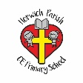 | Where could we go on our holiday? – Summer Term 2  Year 1 Geography
Key vocabulary | Explanation/ definition | Key knowledge
Country | A nation with its own government, occupying a particular territory. | To recognise/identify/describe (GD compare and contrast) the characteristics of the four countries of the United Kingdom and its surrounding seas.
Island | A piece of land surrounded by water. | They can identify where they have been on holiday using a map.
Land | The part of the earth’s surface that is not covered by water. | They can talk about places seen in books, videos and on the internet.
Sea | Salt water that covers most of the earth’s surface and surrounds its land. | They can use basic geographical vocabulary to refer to key physical and human features. Such as Human: city, town, village, factory, farm, house, office, port, harbour, shop) Physical: beach, cliff, forest, hill, mountain, sea, ocean, river, soil, valley, vegetation, season, weather.
beach | A pebbly or sandy shore, especially by the sea. | They can use simple physical and human atlas maps plus terrestrial and aerial photographs to gather information
cliff | A steep rock face, especially by the edge of the sea. | They understand the concept of close and far away.
forest | A large area covered with trees and undergrowth. | 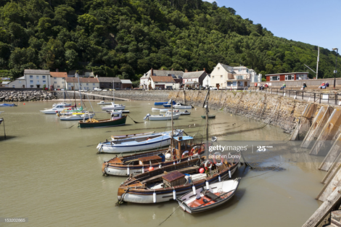
hill | A naturally raised area of land, not as high as a mountain.
mountain | A large natural elevation of the earth’s surface rising abruptly from the surrounding level.
ocean | A very large expanse of sea.
river | A large natural stream of water flowing into a channel to the sea or another river. | Town | A built up area with a name larger than a village but smaller than a city.
soil | The upper layer of earth in which plants grow. | City | A large settlement with a huge population.
valley | A low area of land between hills and mountains. | Village | A group of houses larger than a hamlet and smaller than a town, situated in a rural area.
Seasons | 4 divisions in the year marked by particular weather patterns and daylight hours. | Port | A town or city with a harbour.
Vegetation | Plants found in a particular area or habitat. | Harbour | A place on the coast where ships may moor.
Should you go down to the woods today? – Spring Term 2
Year 1 Geography
Key vocabulary | Explanation/ definition | Key knowledge
Diagram | A simplified drawing showing the appearance, structure or workings of something. | They can record/describe/observe what they have seen on the walk in simple ways, including pictures (using a digital camera), diagrams with labels and oral discussion. (GD recall)
Labels | A phase or name applied to a person or thing. | They can use simple blocked maps and plans.
Compass | An instrument which shows the direction of magnetic north and bearings from it. | They can make simple plans.
North | The direction to usually where a compass needle points. | They can mark the location of the school on a simple local map.
South | The direction pointing towards the horizon. | They know and can use the four points of the compass.
East | The direction towards the point of the horizon where the sun rises.
West | The direction towards the point of the horizon where the sun sets. | 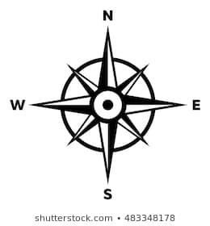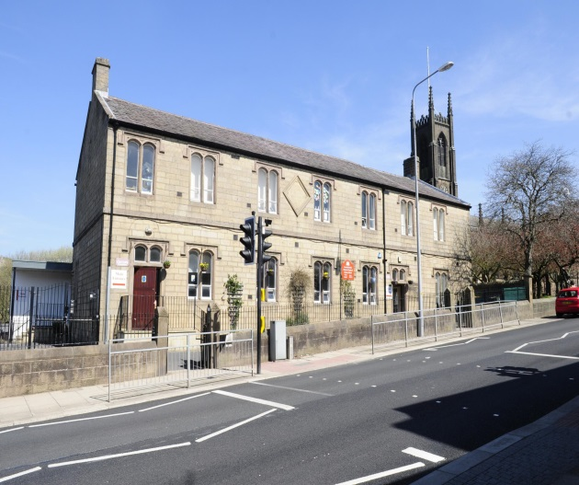
Map | A diagram representation of an area of land or sea showing physical features.

The Great Fire of London – Summer Term 1
Year 1 Geography
Explanation/ definition | Key knowledge
A nation with its own government, occupying a particular territory. | To name the 4 countries of the United Kingdom. (Scotland, England ,Wales and Northern Ireland.)
A piece of land surrounded by water. | To locate the 4 countries on a map of the United Kingdom.
The part of the earth’s surface that is not covered by water. | To name and locate the 4 capital cities of the United Kingdom. ( Edinburgh, London, Cardiff and Belfast.
Salt water that covers most of the earth’s surface and surrounds its land. | To name the 5 Oceans ( Pacific, Atlantic, Indian, Southern, Arctic)
The city that functions as the seat of government and the administration centre of a country. | To know we live in England.
A very large expanse of sea. | To locate the four points on a compass. North, South, East and West.
Country in the United Kingdom. | 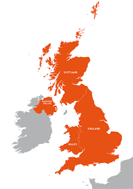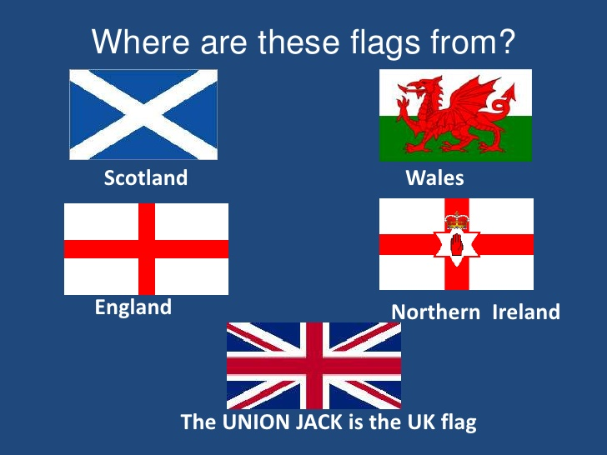
Country in the United Kingdom.

Country in the United Kingdom.

Country in the United Kingdom.

Country in the United Kingdom
Capital city of England. | Belfast – Capital City of Northern Ireland.
Capital city of Wales.

Seasons. On-going through the year.
Year 1 Geography
Key vocabulary | Explanation/ definition | Key knowledge
Weather chart | A map showing the state of the weather over a large area. | They can construct basic symbols in a key.
Climate | The weather conditions prevailing in an area. | They can collect simple statistics about the weather.
Season | Each of the 4 divisions of the year marked by particular weather patterns. | They can fill in a class weather chart.
Spring | The season of the year between winter and summer lasting from March to June. When weather becomes warmer, leaves and plants start to grow and flowers may appear. | They can discuss changes in weather and seasons from a chart.
Summer | The seasons on the year between Spring and Autumn. It is the hottest of the 4 seasons and the days are longest and nights are shortest. The season is from June until September.
Autumn | The season of the year between summer and winter. The season lasts from September to November. The temperature cools and the leaves fall off the trees.
Winter | The season of the year between Autumn and spring. It is the coldest of the 4 seasons and the nights are longer and the days are shorter. The Winter season is from November until March. | 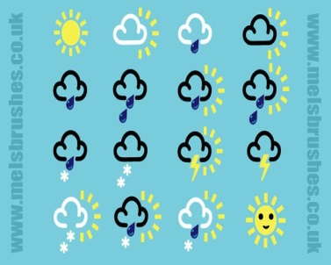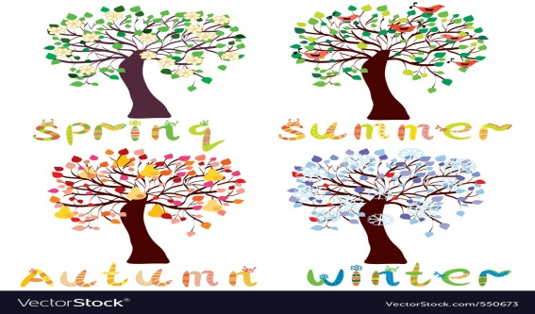
Pattern | An expected action.
Symbols | The pictures that represent the weather.
clouds | A mass of condensed water high above the ground.
Sun | The light or warmth received from the earth’s sun. | Ice | Frozen water.
Rain | Moisture of the atmosphere falling visibly in drops. | Fog | A thick cloud of tiny water droplets that restricts visibility.
Wind | Natural movement of the air blowing in a current direction.
Snow | Frozen water vapours falling in light white flakes or lying on the ground as a white layer.

