Timeline of events.
1666 | 1799 - 1847 | 1815-1842 | 1820 - 1910 | 1851 - 1925 | 1930 - 2012 | 1969
The Great Fire of London | Mary Anning | Grace Darling. | Florence Nightingale. | Lord Leverhulme. | Neil Armstrong | The Apollo 11.

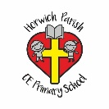 | Superheroes – Florence Nightingale  Autumn 1 Year 1 History.
Key vocabulary | Key knowledge
Nurse  Somebody who works in a hospital treating patients.  Crimean war  The war that Florence Nightingale served in.  Infection  An illness caused by spreading germs.  Red Cross  The award given to Florence for the amazing things she did.  Patient  A person who is ill in hospital.  Wound  An injury where the skin is cut or broken.  Compassion  Concern for the sufferings or misfortunes of others.  Community  A group of people sharing the same location. | Who was Florence Nightingale?  Florence Nightingale was a British nurse born 12th May 1820 in Florence, Italy. She was the daughter of an upper-class couple. She longed to be a nurse, but her father wouldn’t allow it as it was not a job that a lady would have. Eventually, she became a nurse in 1853. | 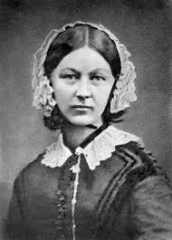  Florence was known as ‘The Lady with the Lamp’ as she carried a lantern with her on night visits to make sure the soldiers were ok.  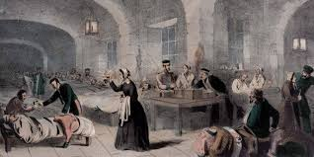  Florence changed the way that hospitals looked after their patients. She changed the way that people thought about nurses. She changed the way that people thought about women.
What were hospitals like before Florence Nightingale?
Before Florence Nightingale, hospitals were overcrowded and there were not enough beds. Hospitals were dirty and had rats and there weren’t enough doctors to help patients.
How did Florence Nightingale Help?
She changed the way hospitals looked after their patients. Florence Nightingale made hospitals cleaner, she gave patients food, she made sure everyone had fresh water and washed their hands regularly and saved many lives. Florence showed that trained nurses and clean hospitals could help sick people get better. Due to this, she is called the founder of modern nursing.
How did Florence Nightingale Help?
She changed the way hospitals looked after their patients. Florence Nightingale made hospitals cleaner, she gave patients food, she made sure everyone had fresh water and washed their hands regularly and saved many lives. Florence showed that trained nurses and clean hospitals could help sick people get better. Due to this, she is called the founder of modern nursing.
In the past…
In the past, most people thought that only male doctors could look after patients and that nurses should only do the tidying up and cleaning. Nurses were not trained. In the past, richest women like Florence got married and looked after their homes instead of working. Florence decided she wanted to work and showed that women could choose to work and do things outside the home.

Florence Nightingale received an award.
Florence Nightingale met Queen Victoria and told her what was wrong with army hospitals. She opened a nursing school called ‘Nightingale Training School for Nurses’ and wrote a book called ‘Notes for Nursing’. In 1970, Florence was awarded the Order of Merit by King Edward VII, she was the first woman to receive this honour.

Timeline of events.
1820 | 1837 | 1851 | 1853 | 1853 | 1854
Florence Nightingale was born on the 12th May 1820. | Florence felt God call her to serve him. She campaigned for better care in hospitals. | Florence became a nurse. | Florence was made superintendent at a medical centre for women in London. | The Crimean War broke out. | Florence went to Turkey to car for wounded soldiers. Florence made sure the hospitals were clean and saved many lives.  Florence was named ‘Lady of the Lamp’ as she cared for people through the night with a lamp in hand.
1855 | 1856 - 1857 | 1859 | 1883 | 1896 | 1910
People gave lots of money to the Nightingale fund for the training nurses. | The Crimean Was ended.  Florence returned to England as a hero | The Nightingale Training School was opened | Queen Victoria awarded Florence the Royal Red Cross. | Florence became so ill she couldn’t leave her bed. | Florence Nightingale died on the 13th August.

Dinosaurs – Mary Anning
Autumn 2 Year 1 History.
Key vocabulary |  | Mary Anning
Archaeologist  A person whose job it is to find and study fossils and historical artefacts. | Existed  Was present in the world as a real thing. | 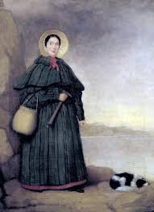  Mary Anning was a famous fossil hunter. She was born in 1799 and lived in Lyme Regis by the sea. Her parents had ten children. Mary and her brother Joseph were the only children to survive to adult hood.  Everyday her father took her and her brother to the beach, where they spent hours looking for fossils. They didn’t actually know that the things they found were fossils or that they were sea creatures from millions of years ago. However, Mary knew that there was something special about the things she found lying in the rocks on the beach, she called them curiosities.  Mary and her family had little money, so Mary and her brother Joseph would take the fossils they had removed from the rocks and sell them for a penny each on a stall. People were amazed by the mysterious shapes of the fossils, thinking they were beautiful and from a mysterious world. Scientists thought these were creatures that had lived millions of years ago.  Sadly, Mary’s father had a fall from one of the cliffs and became very ill. He died when Mary was 12 years old. With no mother or father to look after them, Mary and her brother were now even poorer.  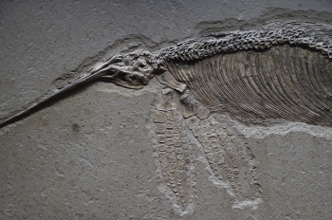  Mary Visited the beach every day looking for fossils to sell. Some years later Mary made an amazing discovery. She had found a giant fossil that no one had ever seen before. IT was the skull of a giant creature that looked like a crocodile. She had found the first complete fossil of an Ichthyosaurus. Scientist from London were amazed by the discovery. Mary was paid for the fossil and her family no longer needed to worry about money.  Mary carried on finding more fossils that the world had never seen before. She found a plesiosaur, a flying reptile and a prehistoric fish. Mary were taken to London and put on display in the British Museum. Mary opened a small shop where she sold fossils, stones and shells.  She died in 1847 after becoming ill, but is remembered as one of the greatest fossil hunters ever to have lived.
Fossils  The remains of a plant or animal which is embedded in rock. | Influential  A lot of importance over people or events.
Jurassic period  The period of time the dinosaurs were alive in. | Jurassic Coast  The name of the coast where Mary Anning made a lot of her discoveries.
Excavates  When earth is moved carefully to find remains | Reptile  A group of cold-blooded animals which have skins covered with small hard plates called scales and lay eggs.
Palaeontologist  A scientist who studies fossils. | Skeleton  The framework of bones in your body.
Century  A period of a hundred years that is used when stating a date. | Scientist  Someone who has studied science and job is to teach or do science research.
Coast  An area of land that is next to the sea. | Extinct  No longer has any living members.
Dinosaur  Large reptiles which lived in prehistoric times. | Carnivore  An animal that eats meat
Discovery  A person who is first to find or become aware of a place, substance or scientific fact that no one knew about before. | Herbivore  An animal that eats plants.
Vertebrate  A creature which has a spine. | Omnivore  An animal that eats plants and meat.

Time line of events
1799 | 1800 | 1810 | 1823 | 1828 | 1847
Mary Anning is born. | Mary Anning was struck by lightning but survived. | Mary Anning discovers her first fossil called an Ichthyosaur. | Mary discovers a Plesiosaurus. | Mary discovers a Pterodactylus. | Mary died aged 47.

Moon Zoon – Neil Armstrong/ Apollo 11
Spring 1 Year 1 History.
Key vocabulary | Why is Apollo 11 moon landing so important? | Key people
Apollo 11  The name given to the mission to land on the moon. | - It was the first time anybody had ever been to the moon.  - On July 16th 1969, Saturn v was launched.  - There were three America astronauts on board; Neil Armstrong, Buzz Aldrin and Michael Collins.  - It took four days to reach the moon.  - Neil Armstrong was the first man on the moon, 19 minutes after Buzz Aldrin joined him.  - They gathered moon dirt and rocks to bring back to Earth. They took photographs to show what the moon was like.  - The moon landing was important because it told us that people could travel there and back safely. It would also help us find out more about space and the moon. | Neil Armstrong  Edwin “Buzz” Aldrin  Michael Collins  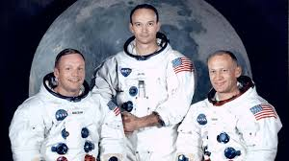  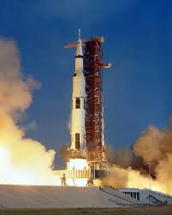
Crew
The team who are taking part in the mission.
Nasa
An American organisation which explores space.
Saturn V
The huge rocket that sent the astronauts to space.
Astronauts
A person who travels in a spacecraft.
Gravity
The force that pulls things to the ground on Earth and other planets.
Outer Space  The universe beyond our solar system. | “One small step for a man, one giant step for mankind”  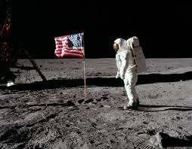  Famously said by Neil Armstrong.
Planet
A large, round object in space that moves around the sun or another star.
Space
The universe beyond Earth.
Star
A massive ball of burning gas that gives off light. The sun is a star.
Universe
Everything that exists in space.
Time line of events
1930 | 1946 | 1955 | 1968 | 1971 | 2012
Neil Armstrong is born. | Neil Armstrong gets his pilot’s license. | Neil Armstrong becomes a test pilot. | Neil Armstrong walks on the moon. | Neil Armstrong becomes a professor at a university. | Neil Armstrong dies.

Into the woods – Lord Leverhulme.
Spring 2 Year 1 History.
Key vocabulary | Key knowledge
Lord  Somebody who has authority, control or power over others, acting like a master.  Apprentice  Someone who is learning a job from a skilled employer.  Business  A place where people work together. People work to make and sell products.  Manufacture  The making of goods.  Established  To do something for a long time and now it is stable/accepted.  Household  A social unit or family living together.  Products  Something manufactured for sale.  Factory  A building where goods are manufactured.  Port sunlight  A model village.  Thornton Manor  A large manor house.  Estate  owning a lot of land to build houses on it.  Public amenities  Elements of comfort and convenience.  Baronet  A member of the lowest hereditary titled British Order. | Lord Leverhulmes childhood.  In 1851 William Hesketh Lever was born. At age 15 he worked as an apprentice in his father’s business, manufacturing and marketing soap and cleaning products. He was made a partner of the business and helped the business expand and develop. | Lord Leverhulme  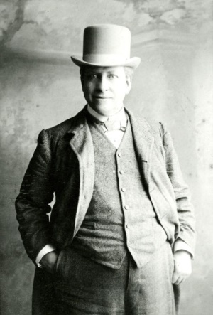
Expanding the business.
William and his brother James established the business of Lever Brothers and began manufacturing sunlight soap in Warrington. They became a household name and their products were sold around the world, including sunlight soap and lux. They needed more space due to increase demand, so made a new factory at Port Sunlight. William rented Thornton Hough.
 | Port Sunlight.  They built a model village at Port Sunlight, including 900 houses, a church, 2 schools, a hospital, the Lady Lever Art Gallery, Hulme Hall, Gladstone Hall, a gymnasium, a heated outdoor swimming pool, various clubs and several bowling greens, some of which are still being used today. | Riverington Terraced Gardens  Rivington Terraced Gardens were originally created for Lord Leverhulme as a place for him to relax in and entertain. Lord Leverhulme wanted a hillside garden with woods and a network of footpaths with bridges and crossings over steep sloops. He built P;aces for him to stay and had formal Lawns and gardens around them. He designed a magnificent 7-arched bridge and also had built a number of summer houses and viewing platforms and the pigeon tower.  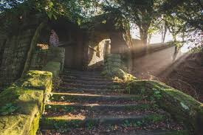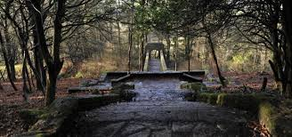
Thornton Manor
Bought Thornton Manor. He then bought the village and made an estate, establishing various public amenities including St George’s Church, a school, the village club, the post office, a new smithy and a village green. Although he had houses at Rivington, Hapstead and Outer Hebrids, Thornton was always his home and where most of his family lived in the village and were buried.
William Lever became a Lord.
William stands for and is elected as a member of Parliament. He goes on to become a baronet and then a Lord. His wife died, in memory of her he added her name Hulme to his name to create the title Leverhulme. In 1925 Lord Leverhulme died.

Time line of events
1851 | 1885 | 1888 | 1888-1914 | 1893 | 1911 | 1913 | 1925
William Hesketh Lever was born. | Lever Brothers was established and began manufacturing sunlight soap. | The business demand increased, so they bought a factory in Port Sunlight. | They built a model village at Port Sunlight for their workers. | William Lever bought Thornton Manor. He then bought the village and made an estate. | William stands for and is elected as a member of parliament. He goes on to become a baronet, Lord and High Sheriff. | Williams wife died, in memory of her he added her name Hulme to his name to create the title Leverhulme. | Lord Leverhulme died.

The Great Fire of London – Summer Term 1
Year 1 History
Key vocabulary | Key knowledge | Key people
Bakery  A place that where bread and cakes are made and sold. | When and where did the fire start?  The Great Fire of London started on Sunday 2nd September 1666 in Thomas Farriner’s bakery on Pudding Lane. | Thomas Farriner  An ember from one of Thomas’ bakery overs ignited some nearby firewood. The firewood quickly spread around the room and to nearby buildings.
Diary  A book that people write about their lives in to record life events. | Why did the fire start?  The fires which was used for baking was not put out properly. | Samuel Pepys (1633-1703)  Famous for keeping a diary for most of the 1660s. He wrote a lot about the Great Fire in 1666. He also played an important part in helping fight the fire by warning King Charles II that more needed to be done on the day the fire broke out.
Eye-witness  A person who has seen something and can give a description of it. | Why did the fire spread so quickly?  In 1666, the houses in Londer were made of wood and straw and they were very close together. This meant it was easy for flames to spread. It had also been a dry summer, so the buildings were dry. Strong winds were blowing at the time of the fire, which helped the flames to spread. | King Charles II (1630-1685)  He ruled England in 1666. He helped the fire fighters, gave rewards to people who tried to stop the fire, and helped people who were hungry and homeless after the fire was over.
Embers  Small pieces of glowing coal or wood in a dying fire. | How did people try to put the fire out?  People used leather buckets and water squirts to try to put the fire out, but these did not work. Later in the week, King Charles II ordered buildings to be pulled down to stop the flames from spreading. | Key places
Fire-hooks  Giant hooks used to pull down houses. | How did the fire stop?  The fire burned for 4days. As the wind died down and changed direction the fire became under control and was finally put out. | London: Capital city of England.
Fire-break  When buildings are destroyed to make a gap so the fire can’t spread. | How many people died?  6 people died as a result of the fire. Thomas Farriner’s maid was the first person to die because she was too scared to jump from the burning building. | River Thames: A river than runs through London.
Flammable  When something burns easily. | What happened after the fire?  13,200 houses were destroyed by the fire and 70,000 people were left homeless. Many left London to live elsewhere and some slept in tents. | St Paul’s Cathedral: The present Cathedral, the masterpiece of Britain’s most famous architect Sir Christopher Wren, is at least the fourth to have stood on the site.
 |  | London Bridge: Bridge that connected London over the River Thames.

Time line of events
Sunday 2nd September 1666 | Monday 3rd September 1666 | Tuesday 4th September 1666 | Wednesday 5th September 1666 | Thursday 6th September 1666
A fire starts in Thomas Farriner’s bakery on Pudding Lane at 1am. As news of the fire spreads, people run to escape its path. | Fire-fighters try to tackle the fire but it spreads quickly. The fire gets very close to the Tower of London. People carry their possessions to safety using a horse and cart or boats on the River Thames. | Houses are pulled down in an attempt to stop the fire spreading. St. Paul’s Cathedral is destroyed by the fire. | The wind starts to die down and the fire starts to burn more slowly. | The fire is finally under control and put out. Thousands of people are left homeless

Seasides – Grace Darling/ Seasides long ago.
Summer 2 Year 1 History.
Key vocabulary | Seasides in the past. | Grace Darling.
Lighthouse  A tower or tall building near the coast with a light used to warn or guide ships at sea.  Coast  The part of the land near the sea.  Lighthouse keeper  A person who is employed to live in and maintain a lighthouse.  Island  A piece of land surrounded by the sea.  Cliffs  A steep rock face closes to the edge of the sea.  Harbour  A place by the seaside where boats can stay safely in the water.  Pier  A structure for people to walk along that is built out into the seaside.  Dunes  Hills or mounds of sand held together by plants, often near the sea.  Bathing machines  Were used by Victorians so they could change in private before getting into the sea.  Punch and Judy  A funny puppet show that has been common at the seaside since Victorian times. | - The word holiday comes from the words ‘holy day’ because a long time ago holidays were based around religious festivals.  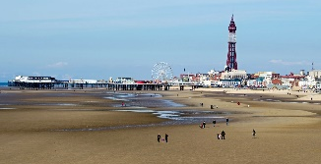  - A long time ago, only rich people went to the seaside because there were no planes, trains or cars to get anyone there. They had to use horse and carriages which were very expensive.  - Rich people started visiting the seaside about 200 years ago.  - Seaside holidays became possible for many people about 150 years ago when steam trains were invented.  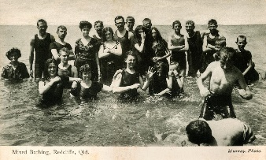  - In the past, before planes were invented, if people went on holiday they would stay within the UK, often heading to the beach resorts e.g. Blackpool, Southport, Bournemouth. People believed that the seaside air was good for you.  - Sunbathing wasn’t in fashion back then, so Victorians would go to the beach fully clothes ‘sea bathing’ was done instead.  - Some beaches were divided for men and women.  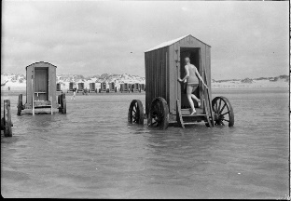  - Beaches were a lot cleaner back then as there was not as many packaged foods and snacks.  - Bathing machines were carriages in which the women would change in to their bathing costumes. A horse would then pull it towards the sea and the women would lower themselves in to it without being seen.  - Punch and Judy is a funny puppet show that has been common at the seaside since Victoria times. | - Grace Darling was born on 24th November 1815, in Bamburgh, Northumberland.  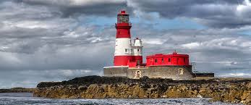  - In 1826 Grace moved with her parents and 8 siblings to the new Lighthouse built at Longstone in the Farne Islands.  - Grace’s Father, William Darling taught all the children to read and write, they did not go to school. Grace and her sisters learnt how to spin, knit, sew and cook.  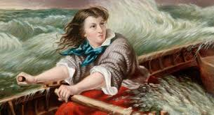  - In 1829 there was only Grace and her younger brother, William, still living at home with her parents. Grace helped her father to look after the lighthouse, but was not allowed to help row the coble as it was considered ‘mens work’.  - On 5th September 1838 the steam ship, Forfarshire, left Hull to sail to Dundee carrying 60 passengers. That evening the ship started to leak, then the engine stopped. The night of the 7th September was stormy and the Forfarshire struck a rock.  - With Grace’s brother away, Grace and her father rowed a big heavy boat, called a coble, between them to rescue the 9 survivors that were clinging to the rock.  - Grace helped to look after the survivors at the lighthouse until the storm stopped, three days later.  - Queen Victoria heard how brave Grace was and sent her £50 as a reward.  - Unfortunately, Grace became very ill four years later and died at the age of 27.

Time line of events
1815 | 1826 | 1834 | 1838 | 1839 | 1842
Grace Darling was born and lived in the Trinity House in the Farne Islands. | 15th February the Darling family moved to their newly built Longstone Lighthouse. | First launching of the 150 ton steamship Forfarshire at Dundee. | Forfarshire crashes on rocks of Farne Island, Grace saves nine survivors. | Both Grace and William were awarded specially minted Royal Humane Society Gold Medals. | Grace dies, she is only 27.

