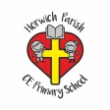 | Year One PSHCE- Keeping/staying safe Road Safety. Term 5
Key vocabulary | Explanation/ definition | Key knowledge
Road | A surface transport travels on. | Developing understanding of safe and unsafe scenarios on a road.  Understand road safety.  Develop road sense.  Explore real life scenario.
Safety | Being protective and unlikely to cause danger
Pelican crossing | An electrical crossing aid.
Zebra Crossing | An unmanned crossing aid
Dangerous | Able or likely to cause harm
Prevention | Action to stop something arising
Accidents | An unfortunate incident

 | Year One PSHCE- Keeping/staying healthy (Hand Washing, healthy eating) Term 3
Key vocabulary | Explanation/ definition | Key knowledge
Soap | A substance used with water to clean things. | Understand how and why we wash our hands.  Germs and how they may spread.  How to prevent spread.  Know the differences between healthy and unhealthy choices
Water | A colourless liquid
Germs | Makes you poorly.
Clean | Free from dirt, marks or stains
Dirty | Unclean
Fruit | Sweet fleshy product of a tree or plant that contains seeds and can be eaten.
Vegetables. | A plant.
Protein | A type of nutrients found in food
Food groups | Groups of nutrients made up in food
Vitamins and minerals | Compounds necessary for the healthy functioning of our bodies

 | Year One PSHCE- Relationships How to be a good friend. Term 2
Key vocabulary | Explanation/ definition | Key knowledge
Friendship | A relationship with others. | Recognises and name a range of feelings.  Caring about others.  How to be a good friend.
Kindness | The quality of being friendly, generous, and considerate
Caring | Displaying kindness and concern for others
Empathy | The ability to understand and share the feelings of another
Body language | The movements used to communicate
Emotions | A strong feeling

 | Year One PSHCE- Being responsible (Water Spillage.) Term 6
Key vocabulary | Explanation/ definition | Key knowledge
Dangerous | Able or likely to cause harm | Importance of preventing accidents  Recognise responsible and irresponsible actions.
Prevention | Action to stop something arising
Accidents | An unfortunate incident

 | Year One PSHCE- Feelings and emotions (Worry, Anger, Jealousy, Grief.) Term 4
Key vocabulary | Explanation/ definition | Key knowledge
Scared | Feeling fearful or frightened | Learn a range of skills for coping with unpleasant / uncomfortable emotions  Be able to recognise and name emotions and their physical effects.  Understanding a range of emotions and how they make us feel physically and mentally.  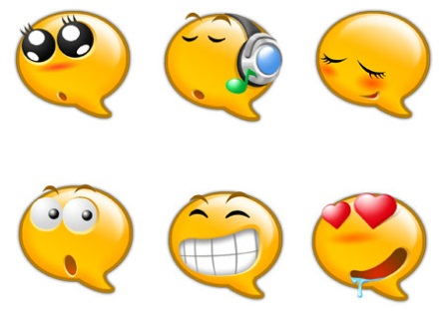
Anxious | Worried or uneasy
Nervous | Alarmed about something
Frustrated | Annoyed or disappointed
Respect | Regard for the feelings, wishes, or rights of others
Unpleasant/Uncomfortable | Causing discomfort or distress
Mental health | Psychological and emotional wellbeing
Reflective | Thinking back over an event in deep thought.
Sad/upset | An emotion.
lonely | A feeling of being on your own.

 | Year One PSHCE- Computer safety (online safety day) Term 1
Key vocabulary | Explanation/ definition | Key knowledge
Privacy | Secrecy- not intruded by others | Understand how your online actions can affect others  Awareness of current games and apps used.  Awareness of computer safety rules.  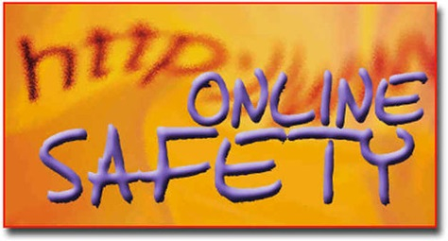
Permission | Giving allowance to someone or something
Passwords | A secret word or phrase
Online | Controlled by or connected to a computer
ICT | Information- communication- technologies

 | Year One PSHCE- Money Sense linked with Year Two and Nat West Bank.
Key vocabulary | Explanation/ definition | Key knowledge
Sensible | Something or someone practical | Understand different ways we can receive money  Know how to keep money safe  Understand the importance of saving money
Saving | The practise of saving money for future use
Resourceful | Having the ability to find quick and clever ways to overcome difficulties
Value | Placing importance on something or somebody
Denominations | A face value of money

