Personal, Social and Emotinal Development/Health and Self Care
Knowledge organiser
Curriculum Expectations | 40-60 M  Confident to speak to others about own needs, wants, interests and opinions.  Can describe self in positive terms and talk about abilities.  Understands that own actions affect other people, for example, becomes upset or tries to comfort another child when they realise they have upset them.  Aware of the boundaries set, and of behavioural expectations in the setting.  Beginning to be able to negotiate and solve problems without aggression, e.g. when someone has taken their toy.Initiates conversations, attends to and takes account of what others say.  Explains own knowledge and understanding, and asks appropriate questions of others.  Takes steps to resolve conflicts with other children, e.g. finding a compromise. |  | ELG  Children are confident speaking to a class group. They can talk about the things they enjoy, and are good at, and about the things they do not find easy. They are resourceful in finding support when they need help or information. They can talk about the plans they have made to carry out activities and what they might change if they were to repeat them.  Children know some ways to manage their feelings and are beginning to use these to maintain control. They can listen to each other’s suggestions and plan how to achieve an outcome without adult help. They know when and how two stand up for themselves appropriately. They can stop and think before acting and they can wait for things they want.Children play group games with rules. They understand someone else’s point of view can be different from theirs. They resolve minor disagreements through listening to each other to come up with a fair solution. They understand what bullying is and that this is unacceptable behaviour.  Health and Self-Care  Children know about, and can make healthy choices in relation to, healthy eating and exercise. They can dress and undress independently, successfully managing fastening buttons or laces.
Term & Topic | Key vocabulary | Explanation/ definition | Key skills and knowledge
Autumn 1  Marvellous Me!  (houses, homes, families)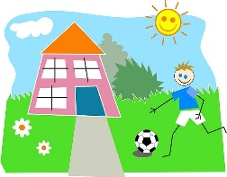 | nervous, anxious, excited | emotions | understand and identify emotions and begin to manage own feelings by using strategies to keep calm eg know and remember from experience that parent always picks up.
 | family, rules, safety, love, respect | Being part of a team and looking after each other | Understand need for safety and cooperation  Use polite manners to ask for what you want eg to play  Begin to share and take turns.  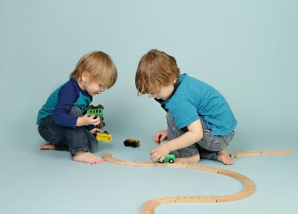
 | Being fair, share  Please may I? Thank you, excuse me, do you want to play with me? Please can I play? | language of negotiation and manners.
Autumn 2  Time to Celebrate!  (light and dark, Diwali, Christmas, celebrations, colour/pattern) | Happy, excited, thankful, grateful  l | Words associated with Christmas and other celebrations when we receive presents/enjoy activities | Being able to explain own feelings  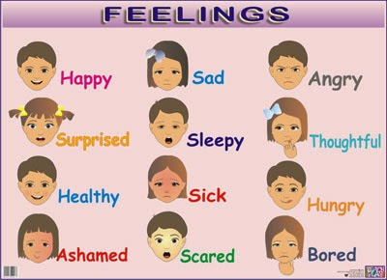
Spring 1  Hats  (people who help us) | Share, take turns, wait  ‘Sharing is caring’ | Words relating to cooperative play  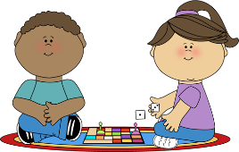 | Children will learn to take turns and share when playing in the role play areas and with other activities
Spring 2  Once Upon a Woodland Walk…  (traditional stories, forest school, plants) | I’m sorry  Apologise  ‘make it better’ | Words relating to resolving conflicts | Based on discussions about the stories, children will develop ideas about how characters can resolve conflicts or how they can ‘make it better’ when things have gone wrong.
Summer 1  Land Ahoy!  (sea life, island life, pirates) | Angry, mad frustrated, cross  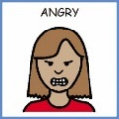 | Feelings words | Learn how to cope with angry feelings (link to Katie Morag story)
 | Safe, danger, careful  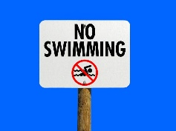 |  | Know the dangers of water and how to stay safe
 | Sharing (recap) |  | Children will understand that we get along with others better when we treat them kindly and share(Rainbow fish story)
Summer 2  A world of stories  (stories from around the world –animals, holidays, ways of life) | Persevere  Try  Talent  embarrassed |  | Know that there are behaviours for different places – in a restaurant, a church, at a park, in the play centre etc..  Know that we have to persevere and try when things are difficult

