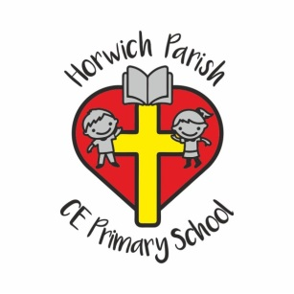
Our Curriculum Journey to Date
June 2020
We started our current journey of curriculum design during the autumn term of 2017, acknowledging the Ofsted focus on the broader curriculum.
- From 2014- this point we used the Cornerstones scheme to drive our foundation subject teaching, with teachers choosing topics from a range intended for their year group.
- In 2017 we looked at the curriculum we were delivering and highlighted this onto year group National Curriculum grids.
- Our curriculum audit showed that: we did not fully comply with delivering all aspects of the National Curriculum; and that there was not a clear progression of skills and knowledge within discrete subjects throughout school.
- We recognised the need to devise a bespoke curriculum, taking into account our context in terms of environment and local history; and the needs of our children and the broader aims of our mission statement.
- From this point onwards we worked as a staff team, and also sought external advice to devise a curriculum which would support progression in knowledge and skills and be engaging and relevant for our pupils. We also wanted to ensure that our curriculum had a foundation in high quality texts appropriate to each year group. We now have a whole school view of the curriculum (grid); updated policies in each subject; links with SMSC within each subject and an ‘at a glance’ view of how each subject is organised.
- Our curriculum audit showed that our assessments within the foundation subjects were not rigorous or helpful to subject leaders, but we recognised that re-designing and delivering a high quality compliant curriculum was the key priority. We have put in place paper assessment grids to be completed by teachers and shared with subject leaders as an interim measure and plan to introduce electronic records on SIMS & spread sheet during Autumn 2019.
- In the academic year 2019/20 we embedded the use of the electronic data system for our foundation subjects and ensured that subject leaders used this as part of the subject development cycle.
- We designed and produced medium term planners for all year groups, including reception.
- We redesigned the curriculum newsletter to provide more succinct information for parents
- Progression ladders were designed for all subjects
- Knowledge organisers were produced for discrete subject areas within topics to ensure a clear focus on essential learning within the teaching sequence.

- Our curriculum design will be on-going as we respond to the needs of our current children and external influences.

