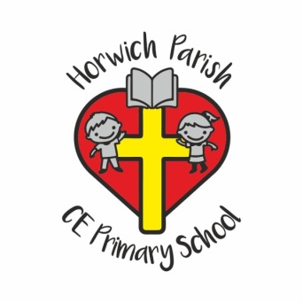
Horwich Parish C.E. Primary School
Photo/Video Consent Form

At Horwich parish CE Primary School, we occasionally take photographs of pupils at our school. We may use these photos in a range of ways including the school’s prospectus, on the school’s website, blogsite and Facebook page and on display boards around school.

We would like your consent to take photos of your child, and use them in the ways described below.
Please tick the relevant box(es) below and return this form to school.

I give permission for photos of my child to be used within school for display purposes.
I give permission for photos of my child to be used on the school website, blogsite.
I give permission for photos of my child to be used for school use on facebook,twitter.
I give permission for videos of my child to be used on the internet for school use including: the school website; blogsite; facebook.
I give permission for photos of my child to be used in any school marketing information (e.g. Open Day Flyers; Production Programmes; School Prospectus)
I give permission for photos of my child to be used by Bolton Local Authority providers that the school uses (e.g. Music Service, School’s ICT Service)
I give permission for photos of my child to be used in the school newsletter.
I give permission for photos of my child to be used in the Bolton News and other newspapers (full names and ages are normally needed for newspapers)
I give permission for videos of my child to be used in the Bolton News and other newspapers (full names and ages are normally needed for newspapers)

Why are we asking for your consent?
To comply with the General Data Protection Regulations rules (GDPR) we need to seek your consent to take and use photos or recordings of your child. We really value using photos of pupils, to be able to showcase what pupils do in school and show what life at our school is like to others, so we would appreciate you taking the time to complete the consent form.
Please be aware this consent will remain in force for the whole of your child’s time at Horwich Parish Primary School. Photographs used on permanent displays and/or in marketing materials may be kept for a reasonable time after your child have left school.
If you initially give consent and then wish to withdraw it at any time, please inform school in writing.

Name of child: ____________________________________________________
Parent/Carer’s signature: ____________________________________ ________Date:_____________________________
Print Nmae____________________________________________Relationship to child______________________________

