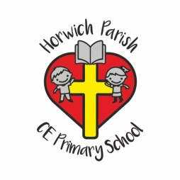

Uniform List
Girls
• School red sweatshirt or cardigan with School Logo.
• Plain white polo shirt or white shirt.
• Dark grey knee length skirt/ Dark pinafore dress/dark grey trousers (No leggings).
• Summer dress in red and white gingham check.
• White/grey socks.
• Sensible black school shoes- not trainers.
• KS1 School Book bag.
Boys
• School red sweatshirt with School Logo.
• Plain white polo shirt or white shirt.
• Dark grey trousers/shorts
• Black/grey socks.
• Sensible black school shoes- not trainers.
• KS1 School Book bag.
PE Kit
• Plain white T-shirt and plain black shorts.
• Black tracksuit for outdoor PE.
• PE black pumps for indoor PE lessons, and trainers for outdoor PE.
• PE Bag
• PE kit is to be kept in a named PE bag in school except when sent home for washing.
Jewellery
No jewellery is allowed except watches from Year 2 onwards. Children with pierced ears may wear plain stud earrings (max one earring per ear). Earrings must be removed or covered in PE lessons.
Hair
Children with hair shoulder length or longer must be tied back with a band. No large head bands or bows. No extreme haircuts are allowed. Nail varnish and false nails are not allowed.

