Things I will need at School
Wellingtons for outdoor play | 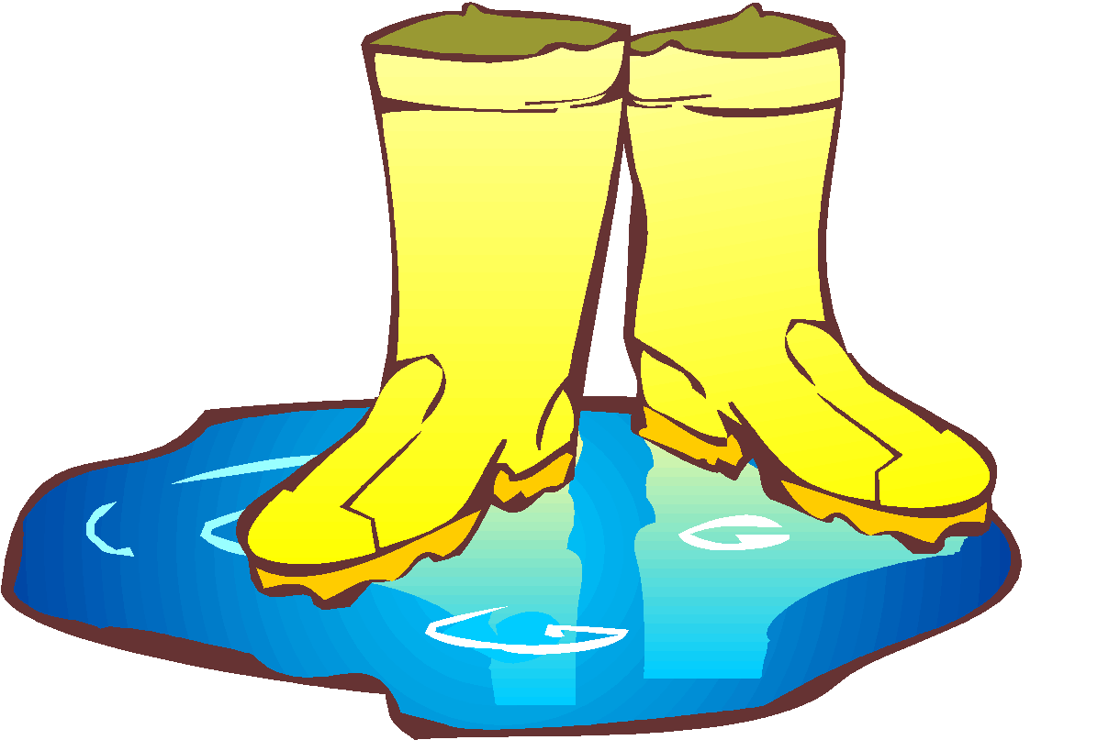
PE Bag, containing white T shirt, black pumps and black shorts. (Please ensure the bag and all its contents are clearly named.) | 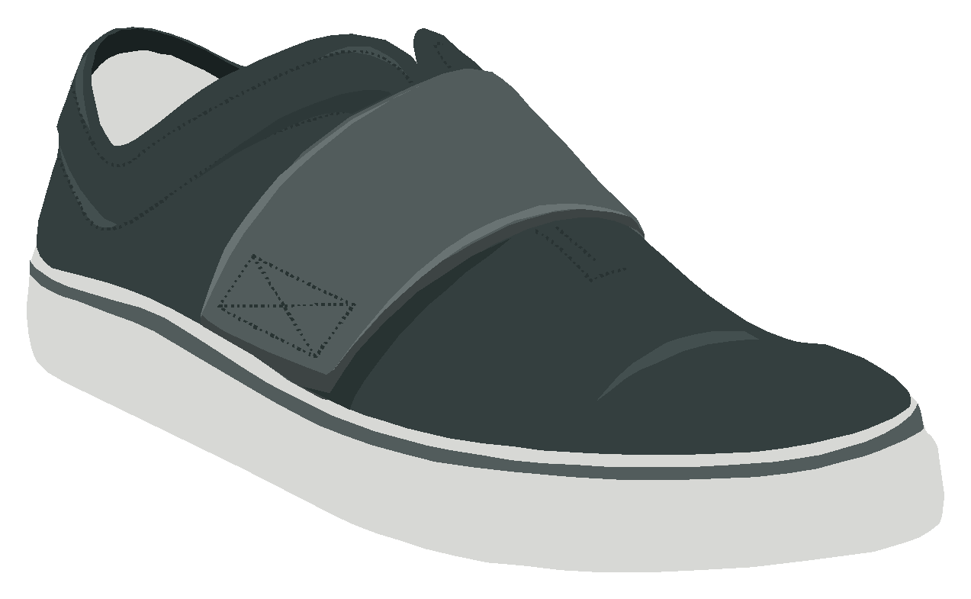
Spare underwear and socks – just in case of toilet accidents or wet feet from water play.
£1.25 per week if you wish your child to be provided with a daily snack (payable online via ParentPay). | 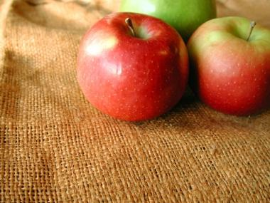
A school book bag.

A coat and other outdoor clothes appropriate to the weather. | 