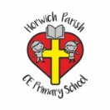 | RE Summer term 1 Year One  Why is baptism special?
Key vocabulary | Explanation/ definition | Key Knowledge
Baptism | Ceremony in which someone is sprinkled/immersed in water as a sign that he or she has become a Christian. | - Baptism is an occasion when promises are made to God and people are welcomed as a member of the church.  - Water is a symbol of baptism.  - People can be baptised at any age, in the font at church, in a pool, a river or the sea.  - Jesus was baptised in the river Jordan.  - People of faiths other than Christianity also welcome new babies in special ways.  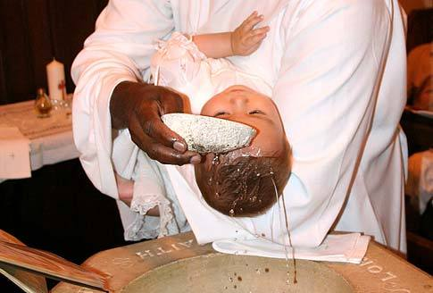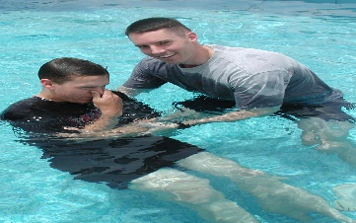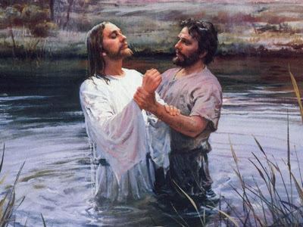
Font | Bowl in a church that holds water for baptisms.
Christening | Christian ceremony in which a child is given a name and made a member of a church.
Vicar | A priest in the Church of England.
Minister | Member of the clergy.
Priest | A person who can administer the sacraments (communion), preach and perform religious ceremonies.
Godparents | A person who promises at a child’s baptism to bring the child up as a Christian.
Water | Used as a symbol of new life during baptism, to remind us of Jesus’ baptism.
Belonging | A close relationship with something/someone (e.g. with God, Jesus, the church).
Key skills
By the end of this unit, pupils are expected to be able to:
- Talk about what belonging means to them.
- Use religious vocabulary such as vicar, priest, font, baptism, church, and prayer.
- Tell you about what happens when a baby is baptised.
- Talk about the ways in which people of other faiths welcome new babies.

