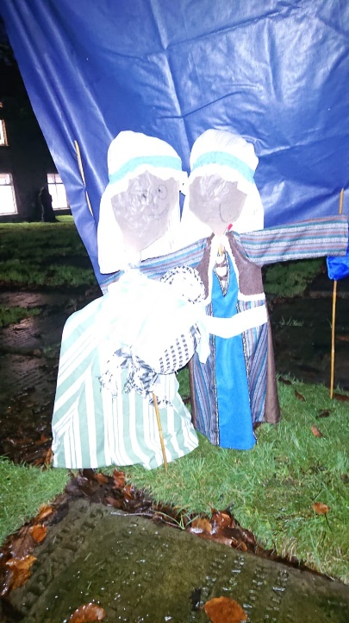
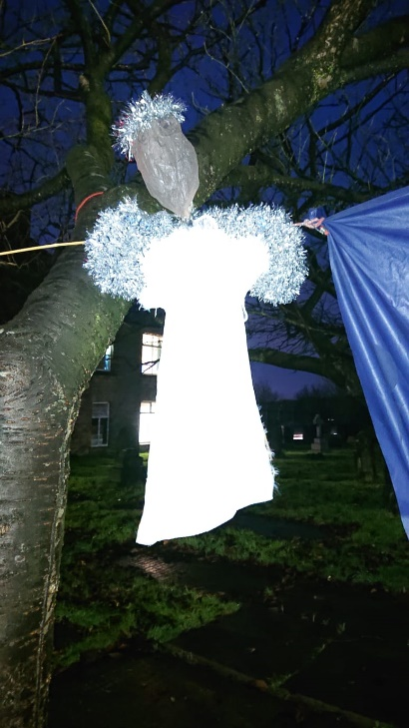
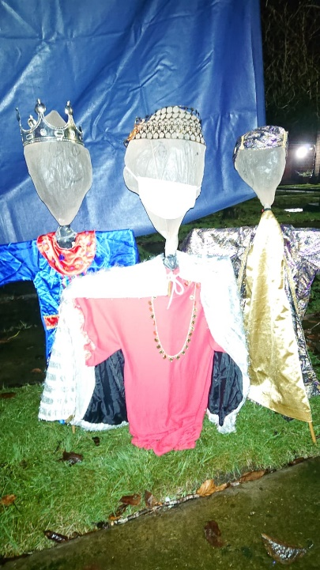

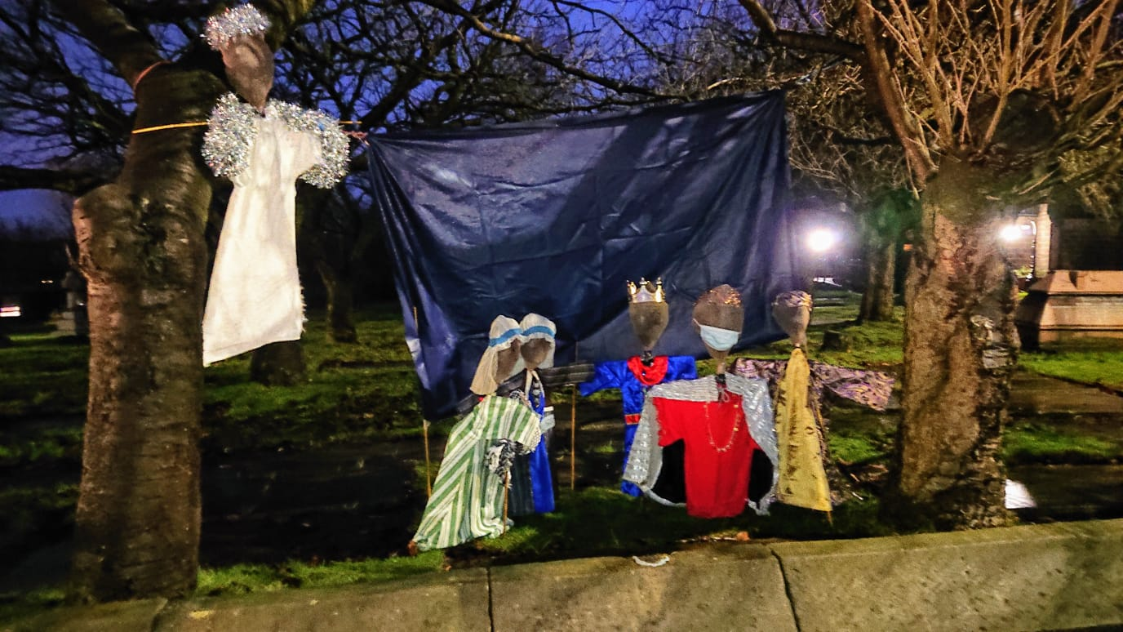
Our Scarecrow Nativity – December 2020
The Reception and Year One children made scarecrows and then dressed them in some of our Nativity costumes. We then created a Nativity tableau in the church yard for everyone to see. Rev. Nicola, Mrs Magilton and Miss McEwan had great fun putting it all together in the dark!!

