Joke 6

Today’s Joke is by Reuben and Family:
Knock, knock
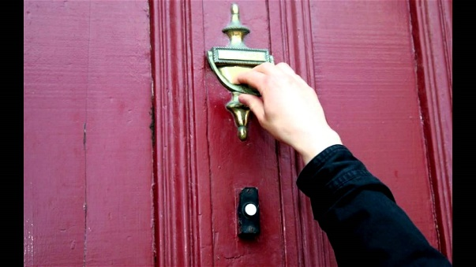
Who’s there?
Atch

Atch who?
Bless you!!!!!

