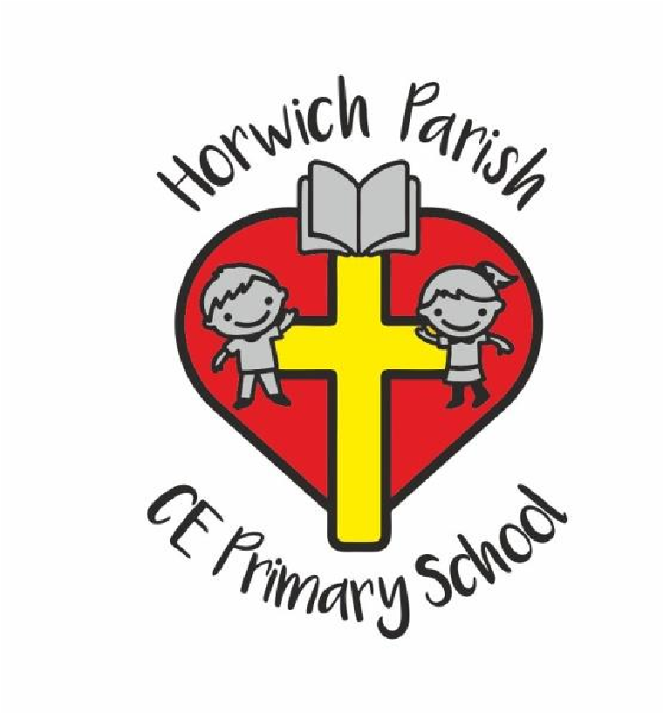
Horwich Parish C.E. Primary School
Church Street
Horwich
Bolton
BL6 6AA
Head Teacher: Mrs D Mills
Telephone: 01204 333147
Email: head@horwichparish.net
“God with us, Lighting the way to love & respect”

Dear Parents
I hope this message finds you safe and well.
We find ourselves in unprecedented and difficult times.
Today would have been our last day in school before the Easter break. The forced closure of our school community with the exception of a small number of children has meant that our usual routines and school events have been cancelled and life as we know it has changed...for now.
A huge thanks goes to the staff at Horwich Parish who have continued to work throughout this week either in school, as a necessity, or at home providing learning activities for the children.
Well done to all our children who have completed work at home! The teachers are able to access the online learning platforms and have been checking participation each day.
Thank you to parents for supporting their child/en`s learning this week. For the next two weeks the teachers have put home learning on their class pages for those who would like to keep to a routine but not essential for those who would like their child to have "down time" over the holiday break.
It would be lovely if the children could continue with the 40 acts of love and submit their completed sheet to their class teacher.
The teachers have been busy answering lots of class emails and dojos this week. We will continue to respond to parents but over the next few weeks I have assigned particular members of staff to answer parents queries regarding work to enable other staff to take a break from school matters and look after their families.
Thank you for the many supportive emails and messages we have received, they have gone a long way to keeping the staff upbeat and positive atmosphere in school.
I will continue to email parents after the Easter break. If I receive any further information from the government I will of course update you sooner. I will be on call throughout the holidays if parents need to make contact with the school as our office will be closed. Please email me at head@horwichparish.net
In conclusion I would like to share this prayer with you.
Keep us, good Lord, under the shadow of your mercy in this time of uncertainty and distress. Sustain and support the anxious & fearful, and lift up all who are brought low; that we may rejoice in your comfort knowing that nothing can separate us from your love in Christ Jesus our Lord.
Amen.
May I wish everyone a blessed Easter. I pray that you will stay safe and well with your family during this time.
Kind regards
Mrs Mills

