Joke 4

What do you call a wobbly helicopter?

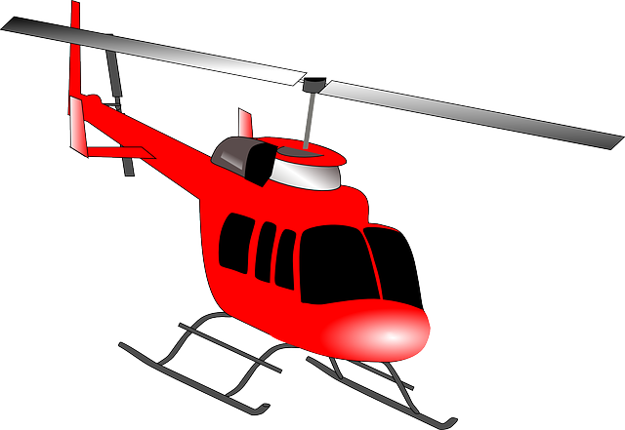

A Jelly-copter!
