Joke 2

How do you make toast in the jungle?

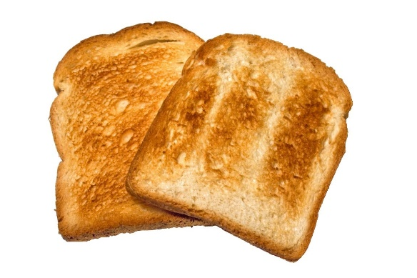

Put it under a 'grilla'

