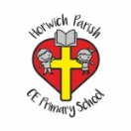 | RE Spring term 2 Year Six  Why do Christians celebrate the Eucharist?
Key vocabulary | Explanation/ definition | Key Knowledge
Eucharist | The substances received during this sacrament, namely the bread and wine, seen as Christ’s body and blood. | - Links can be made between Christian beliefs, the Eucharist, the Last Supper and the Passover.  - There is important symbolism associated with the Eucharist that explains Christian Belief.  - Christians celebrate the Eucharist and why it is important.  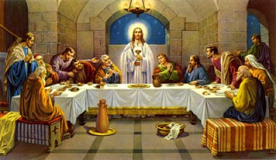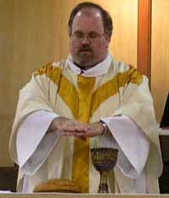  The Last Supper Eucharist
Holy Communion | A religious service in the Christian church, in which people share bread and wine as a symbol of the Last Supper and the death of Christ.
Last Supper | The supper eaten by Jesus and his disciples on the night before the Crucifixion, as recorded in the New Testament and commemorated by Christians in the Eucharist.
Remembrance | Honouring the memory of a person or event.
Holy | Relating to God.
Sacrifice | Giving up of something valuable or important to help someone or something else.
Mercy | Compassionate or kindly forbearance (refraining from something) shown toward an offender, an enemy, or other person in one’s power; compassion, pity, or benevolence.
Salvation | - The act of saving or protecting from harm, risk, loss etc.  - The deliverance from sin and it’s consequences, believed by Christians to be brought about by faith in Christ.
Key skills
By the end of this unit, pupils are expected to be able to:
- Use good religious vocabulary to show understanding of why Christians celebrate the Eucharist.
- Identify the similarities and differences within and between the way Christian denominations celebrate the Eucharist.
- Ask thoughtful questions about the words and actions of the Eucharist service.
- Talk about the way in which the Eucharist service answers questions about Christian beliefs.
- Explain what the words remembrance, holy, sacrifice, mercy, salvation and faith mean in Christianity and in their own lives.
- Suggest reasons for the similarities and differences between denominations.

