Key vocabulary
heart | The heart pumps blood around your body.
pulse | Each time the heart beats it can be felt as a pulse in the arteries. Typically, in the wrist and neck.
blood | The red liquid pumped around the body by the heart. It transports oxygen, nutrients and water to all the parts of the body.
blood vessels | The narrow tubes which our blood flows through including the arteries, veins and capillaries.
lungs | Two organs situated in the ribcage that fill with air when you breathe in. They remove carbon dioxide from blood and add oxygen.
circulatory system | This circulates blood through the body. It consists of the heart, blood and blood vessels.
diet | The sort of food animals or humans regularly eat.
exercise | Activity that requires physical effort, carried out to sustain or improve health and fitness.
drugs | A medicine or other substance that has an effect in a person’s body.
lifestyle | The way in which a person lives.
Our pulse rate increases when we do exercise.

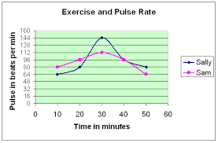
Animals including humans – Year 6
Significant scientist
William Harvey  (1578-1657)  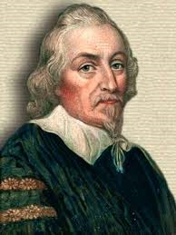 | William Harvey was an English physician and the first person to correctly describe blood’s circulation in the body. He showed that arteries and veins form a complete circuit.

Healthy bodies
Diet, exercise, drugs and other lifestyle choices have an impact on how our bodies function. This can affect how well our heart and lungs work and how fit and well we feel.
Some choices such as smoking, drinking alcohol and obesity can be harmful to our health:
Alcohol
Too much alcohol can damage the liver, heart and stomach.
Smoking
Can cause shortness of breath, heart and lung disease.

Why is exercise so important?
Exercise can increase fitness, make you feel physically and mentally healthier, strengthen your heart and improve your lung function.

© ECM Education Consultants 2019

The human circulatory system
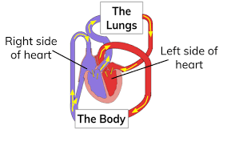
- The heart pumps blood in the blood vessels to the lungs where oxygen goes into the blood and carbon dioxide is removed.
- The blood goes back to the heart.
- It is then pumped around the body so that water, nutrients and oxygen are transported in the blood to the muscles and all the other parts of the body where they are needed. As all these are used, they produce carbon dioxide and other waste products.
- Carbon dioxide is carried by the blood in blood vessels back to the heart.
- The cycle starts again as the carbon dioxide is then transported back to the lungs to be removed from the body.
The circulatory system transports nutrients and water in the blood to all the parts of the body that need them. These nutrients provide us with energy.

