Frozen Kingdom – Spring Term 1
Year 6 Science
Key vocabulary | Explanation/ definition | 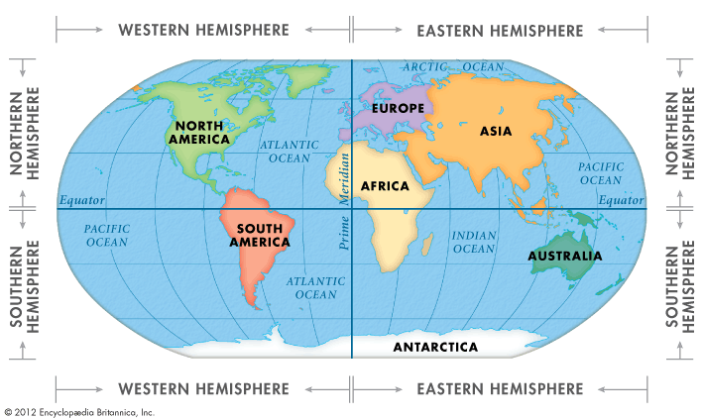  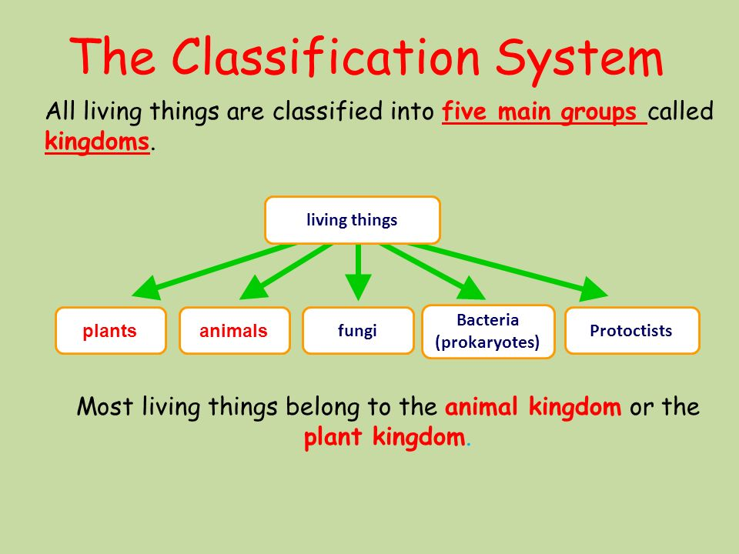
Antarctica | A polar region around the Earth’s South Pole.
Arctic | A polar region located at the northern most part of the Earth (North Pole).
vertebrates | Animals with a backbone
invertebrates | Animals without a backbone
echinoderms | Marine invertebrates : including starfish
Biodiversity | A variety of things living in a given place.
classification | Classification is a system used by scientists to describe organisms, or living things. To classify things means to place them in different categories, or groups
Micro-organism | Microorganisms, or microbes, are a diverse group of minute, simple forms of life that include bacteria, algae, fungi, protozoa, and viruses
Food chain | A diagram to show how each living thing gets food.

Frozen Kingdom – Spring Term 1
Year 6 Geography
Key vocabulary | Explanation/ definition | Key knowledge
Antarctica | A polar region around the Earth’s South Pole. | Antarctica is known as the windiest, coldest and driest continent. It is considered a desert due to its low rainfall.
Arctic | A polar region located at the northern most part of the Earth (North Pole). | Arctic region is made of an area with a number of natural resources: fish, oil, gas and various minerals is almost covered in water, most of which is frozen.
Expedition | A journey undertaken by a group of people | Animals found in the Antarctica include: penguins, whales , seals and range of se birds
Iceberg | A large mass of ice that has broken away from a glacier and is floating in the ocean. Ice sheet A very large | Animals found in the Antarctica include: polar bears, arctic foxes, seals, whales.
Ice shelf | Ice that is attached to land but projects out to sea. | Sir Ernest Shackleton is one of the most inspirational polar explorers in history, yet never actually reached his goal - the South Pole.
Southern hemisphere | the half of the Earth that is south of the Equator | Roald Amundsen was one of the most important explorers to have ever lived. The Norwegian explorer was the first ever to reach the South Pole in 1911.. In 1926, Amundsen successfully reached the North Pole as well - making him the first man in history to reach both poles.
Northern hemisphere | the half of the Earth that is north of the Equator | 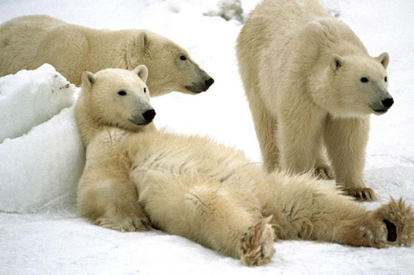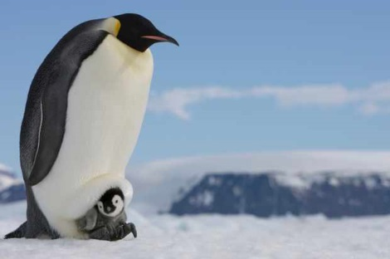
Global warming | global warming is the long-term rise in the average temperature of the Earth's climate system.
Polar regions | polar habitats are located in the very north and very south of the globe – the two pole ends of the Earth. The northern polar region is called the Arctic, and in the south the polar region is the continent of Antarctica. Polar habitats have just two seasons – summer and winter.
biomes | An area providing a specific habitat

Frozen Kingdom – Spring Term 1
Year 6
History

Key vocabulary | Explanation/definition | Key knowledge | Key people and places

Time line of events

