Maths

This term the children will be learning Place Value and Addition and Subtraction.

We will be learning:

* Recognise, partition and write numbers to 100.
* Show 10s and 1s on the number line to 100.
* Estimate numbers on a number line.
* Bonds to 10 and 11.
* Add three 1 digit numbers.
* Add and subtract across a 10.

RE

We will be learning about: ‘Who is Jewish and how do they live?’

We will be learning:

* Jewish worldviews and ways of life.
* Texts from the Torah and their importance to Jewish people today.
* What the mezuzah and the Shema prayer mean for believers.
* Why Jewish people mark the Shabbat and Chanukah.

Science

We are going to be learning about Plants!

We will be learning:

* What is a plant?
* Parts of a plant.
* Wild and garden plants.
* Deciduous and evergreen trees.
* Sorting seeds.
* Which plant parts can you eat?

History / Geography

This term we will be focusing on Geography- ‘Why is our world wonderful?

We will be learning:

* What are some of the UK’s amazing features and landmarks?
* Where are some of the world’s most amazing places?
* Where are our oceans?
* What is amazing about our local areas?
* Why are natural habitats special and how can we look after them?

PE

This term we will be focusing on fundamental movements. These include skills like running, jumping, throwing, catching, balancing and kicking.

PSHE

This term the children will be learning about Families and Relationships.

We will be learning:

* The role of family in our lives.
* Families are all different.
* To recognise how others show feelings in different ways and how to respond.
* To how deal with unhappy friendships.
* To understand the conventions of courtesy and manners.
* To understand the process and emotions relating to grief.
* To develop an understand of stereotypes and how these might affect job/career choices.

Music

This term the children will be using instruments to represent animals, copying rhythms and creating call and response rhythms.

We will be learning:

* To create short sounds with varied dynamics that represent an animal.
* To copy a short sound pattern.
* To explore call and response using instruments.
* To create sound patterns based on call and response.
* To perform different sound patterns with contrasting dynamics.

**Art / DT**

We are doing DT, Structures: Constructing a windmill

We will be learning:

* To create a stable structure.
* To use tools and equipment accurately to make part of a structure.
* To join parts of a structure.
* To evaluate a structure.

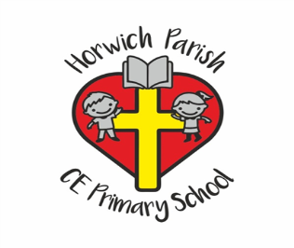

Year 2

Autumn 1

English

The children will write a diary entry about a space flight based on ‘Look Up’, by Nathan Bryon.

Computing

This term the children will be learning about staying safe online.

We will be learning:

* What happens when I post online?
* How do I keep my things safe online?
* How to recognise when to deny permission online.
* How to recognise that not everything online is true.