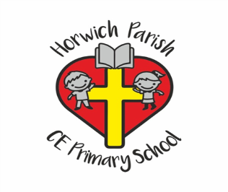

Year 5

Autumn 1

**English** 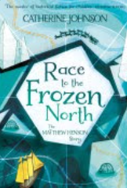

In writing skills we will be using ‘Young, Gifted and Black’ as well as ‘Race to the Frozen North’ to create a diary entry.

In reading skills, we will be reading ‘Viking Boy’

**Science**

We will be studying mixtures and separation with a focus on methods of separating.

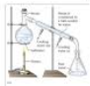

PE 

Swimming

Fundamental Movement

**RE**

We will be studying what it means to be a Muslim in Britain today.



**PSHE**

We will be learning about families and relationships.



**Music**



We will be studying composition notation.

**DT**

This half term we will be studying electrical systems and creating electrical doodlers.

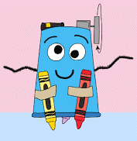

**Geography**  

In geography we will be carrying out a geographical study of The Alps.

**Maths**  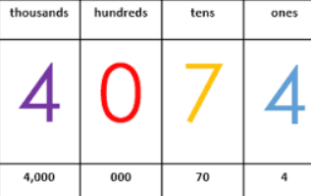

Number and Place Value

Addition and Subtraction

Multiplication and Division

**Computing**

Throughout this half term, we will be studying internet safety.