RE

What does it mean to be a Muslim in Britain today?

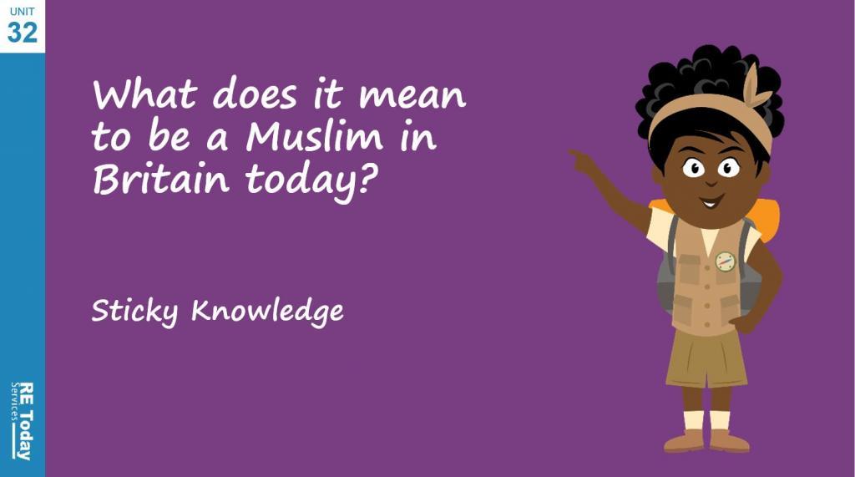

Music

Dynamics, pitch and texture

Appraising the work of Mendelssohn

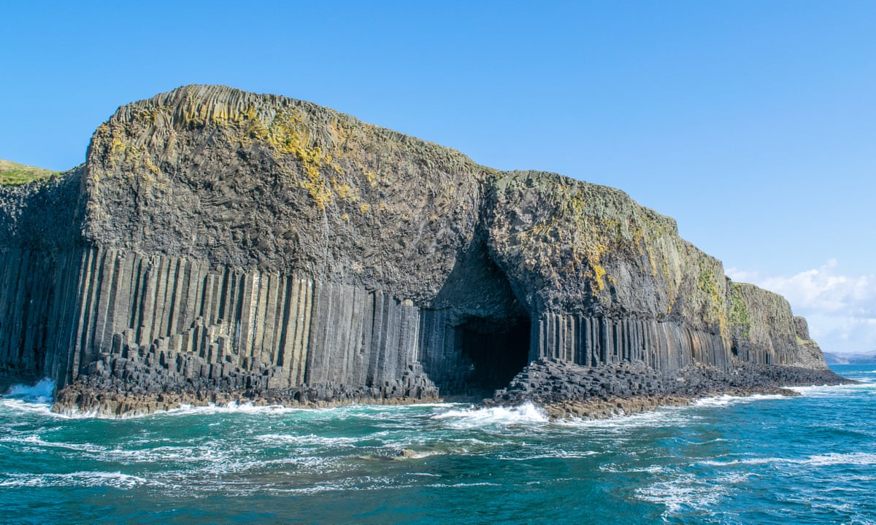

Maths

Place value

Rounding

Adding and subtracting

Multi-step problems

English

We will be reading the novel ‘Holes’ by Louis Sachar. Also, we will be enjoying non- fiction books linked to classification. We will be writing an action-packed story ending based on the book King Kong by Anthony Browne.



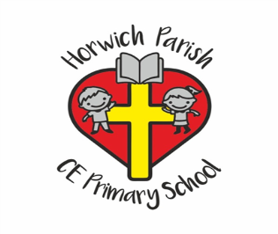

Year 6

Autumn 1 2025

PE

Speed Agility Quickness

PSHE

Families and Relationships

Design Technology

Design a steady hand game of your own according to your design criteria, using four different perspective drawings

Geography

What is life like in the Alps?

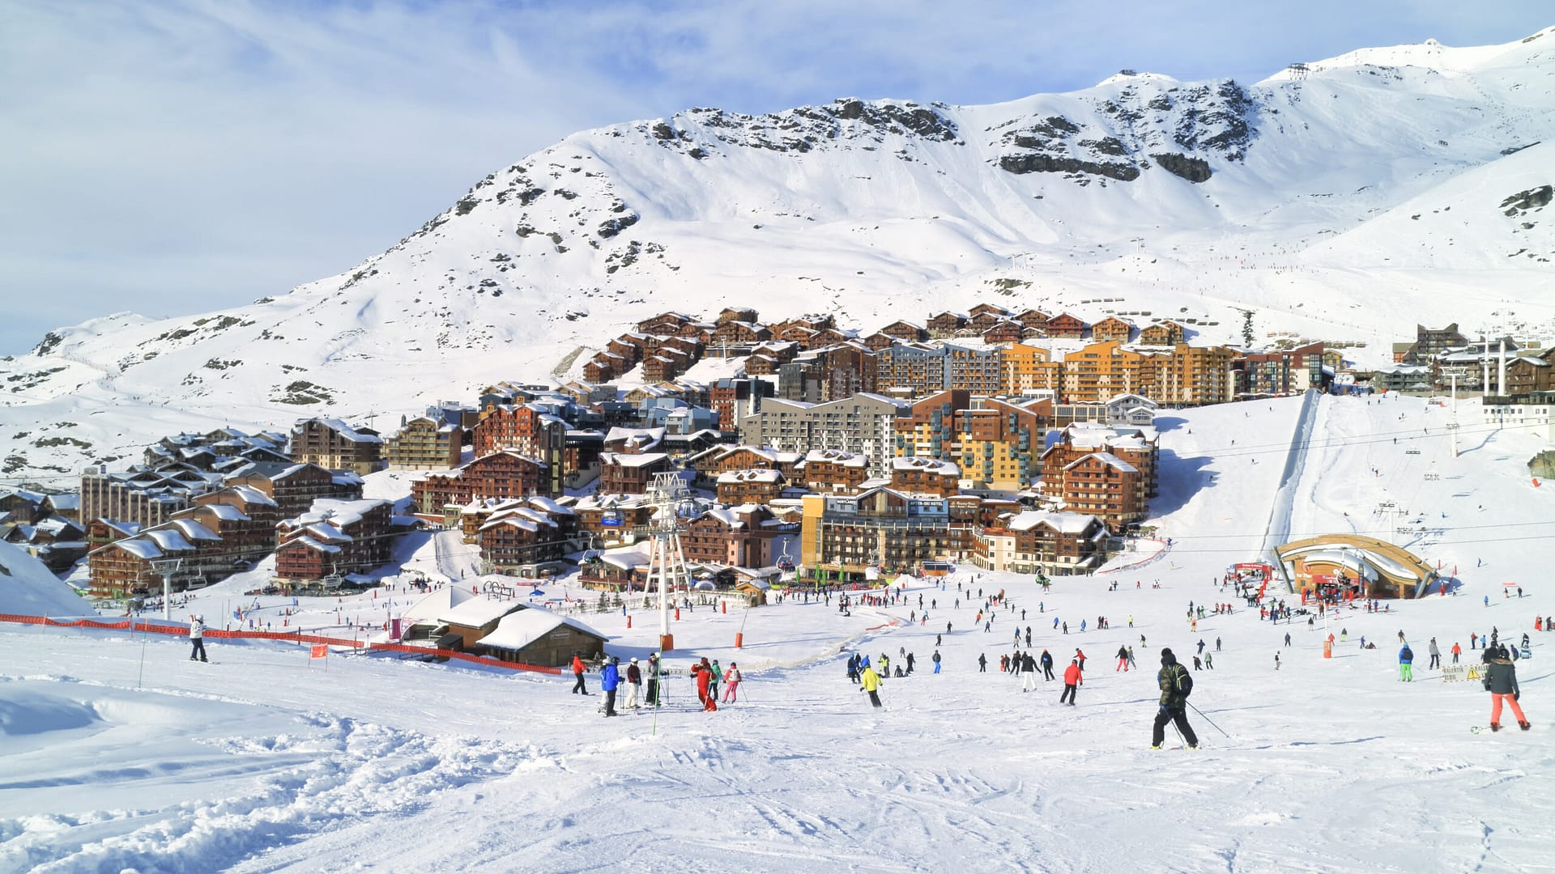

Science

‘Living things and their habitats’ - this will involve learning about the classification of animals, the scientist Carl Linnaeus and all about micro organisms.

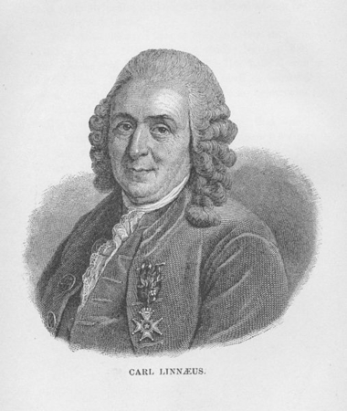

Computing

Online safety 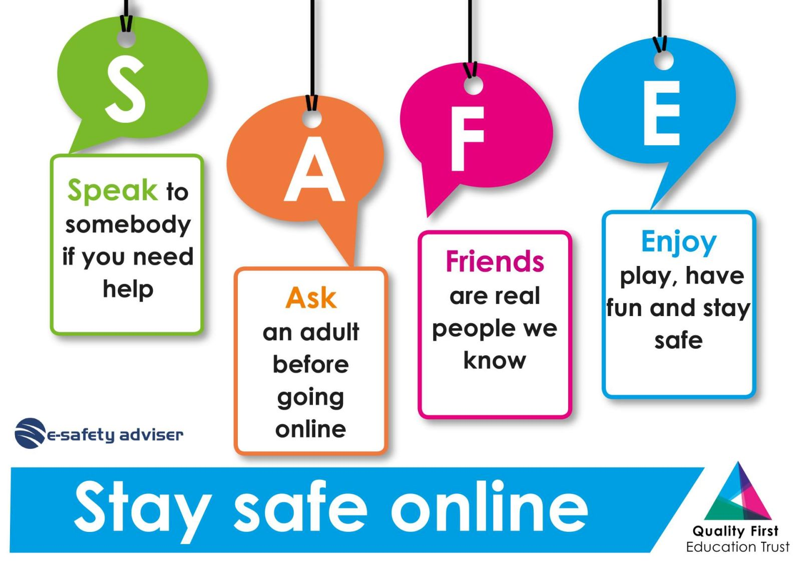

Computing systems and networks: history of computers