Computing 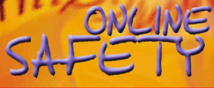

Online safety

We will be learning about:

* What happens when I search online?
* How do companies encourage us to buy online?
* What is a bot?

Art / DT 

**We are doing DT this term and we will be doing digital world: mindful moment timer**

We will be:

* Analysing timers
* Designing for the user
* Programming the timer

PSHE 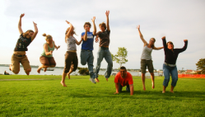

This term the children will be learning about Families and relationships

We will be learning about:

* Respect and manners
* Healthy relationships
* How my behaviour affects others?

PE 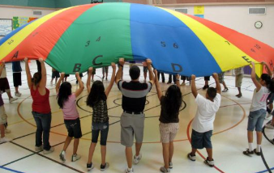

This term we will be focusing on fundamental movements.

Science 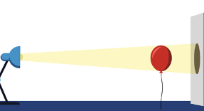

We are going to be learning about Light and Shadows

The children will learn about:

* The source of light
* What is reflection?
* Where do shadows come from?

History / Geography 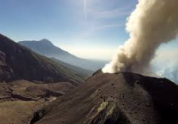

This term we will be focusing on Geography- Why do people live near volcanoes?

We will be learning:

* How is the Earth constructed?
* Where are mountains found?
* Why and where do we get volcanoes?

Music 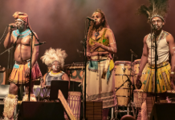

South Africa (instrumental lessons)

We will be learning

* Minims
* Semibreves
* Crotchets and rests

RE 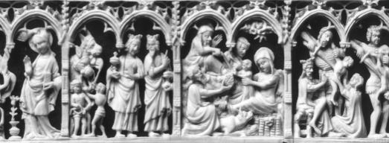

We will be learning about: What did Christians learn from the creation story?

We will be learning about:

* The creation story
* Our opinions
* Opinions of Christians

English

The children will learn how to write a narrative based on the story of ‘Gorilla’.

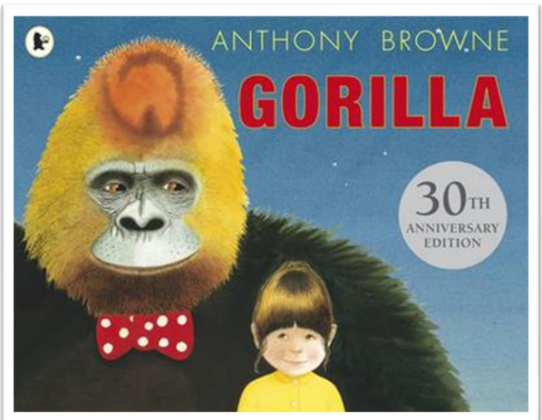

Maths 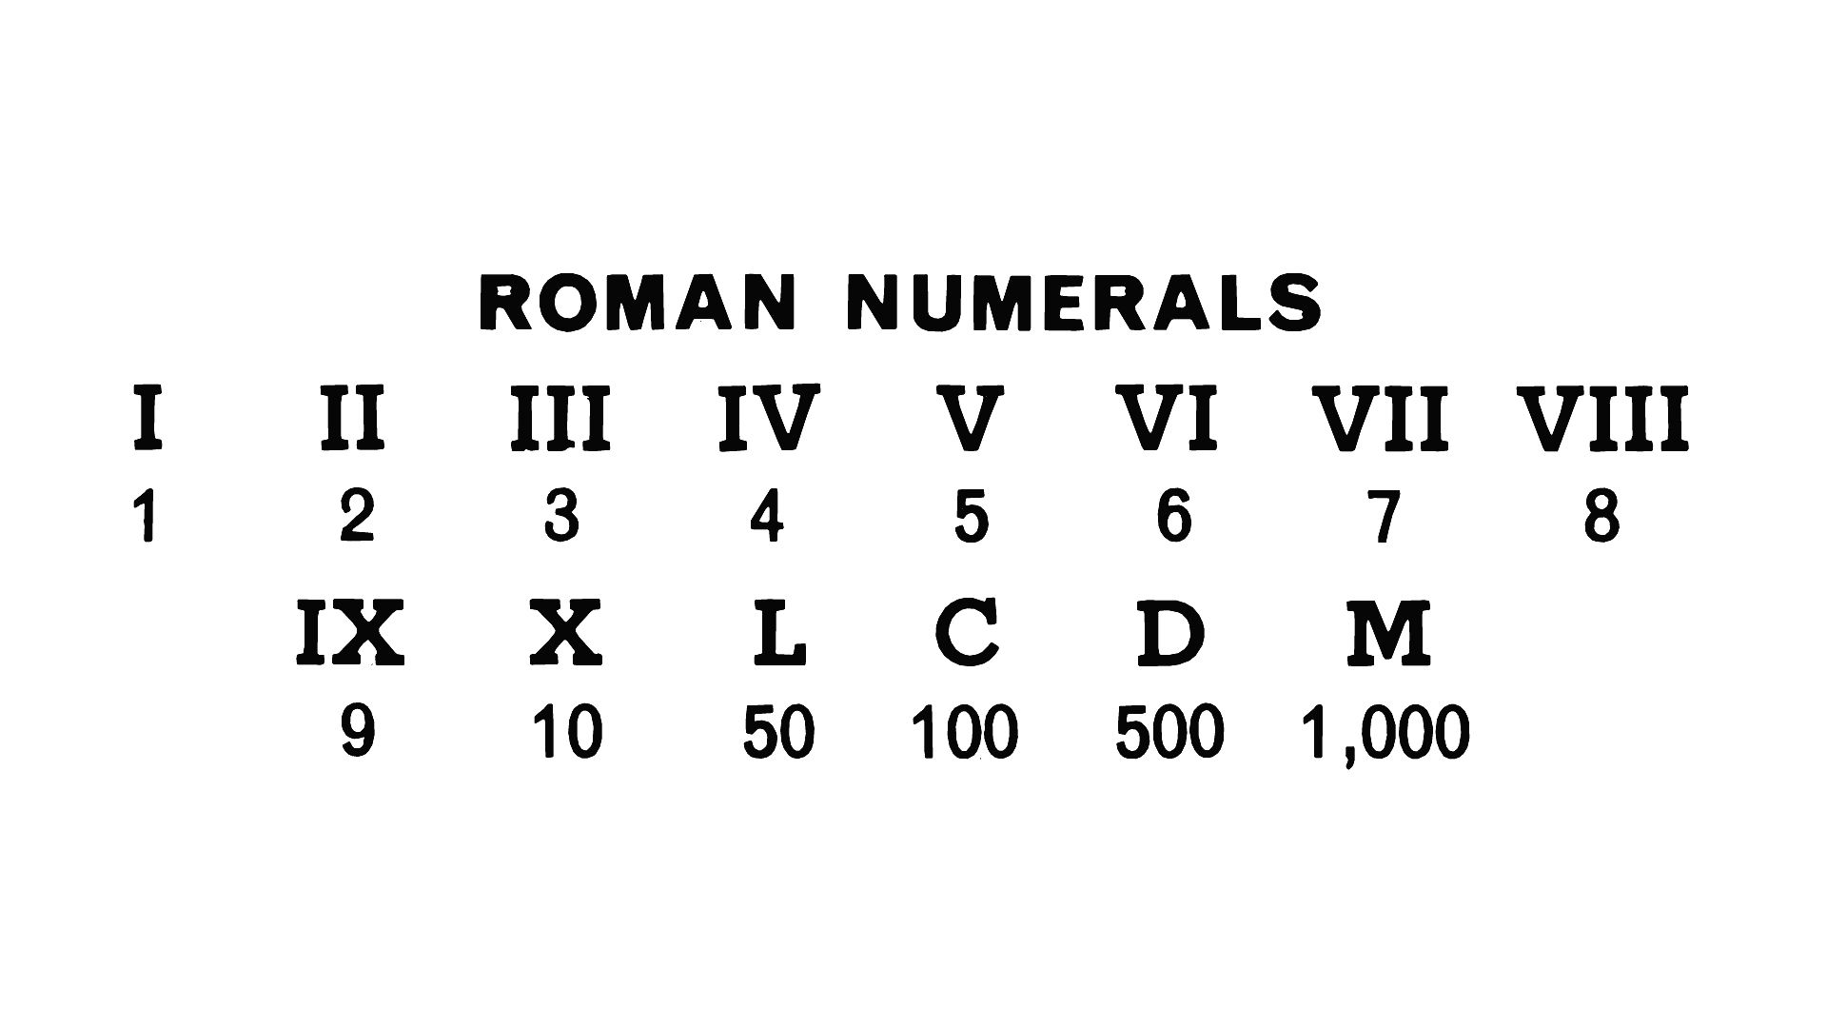

Place Value

Children will learn how to:

* Roman numerals
* Partitioning
* Number line to 10,000
* Numbers to one million

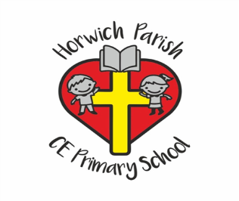

4/5H

Autumn one