Science

In the topic ‘Seasonal Changes’ we will focus on learning the four seasons of the year and making connections between weather patterns and the changes in trees.

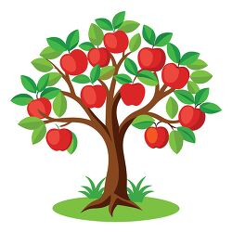

RE

We will be exploring the key question ‘Who is Jewish and how do they live?’



Music

Keeping the pulse

Exploring percussion



Maths

Place value

Addition and Subtraction

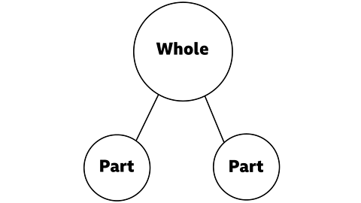

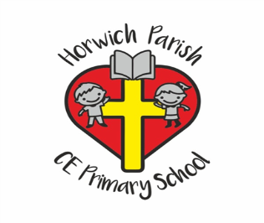

Year 1

Autumn 1 2025

Computing

Online safety – In this topic children will have an introduction to the online world and learn the key rules of keeping safe online.

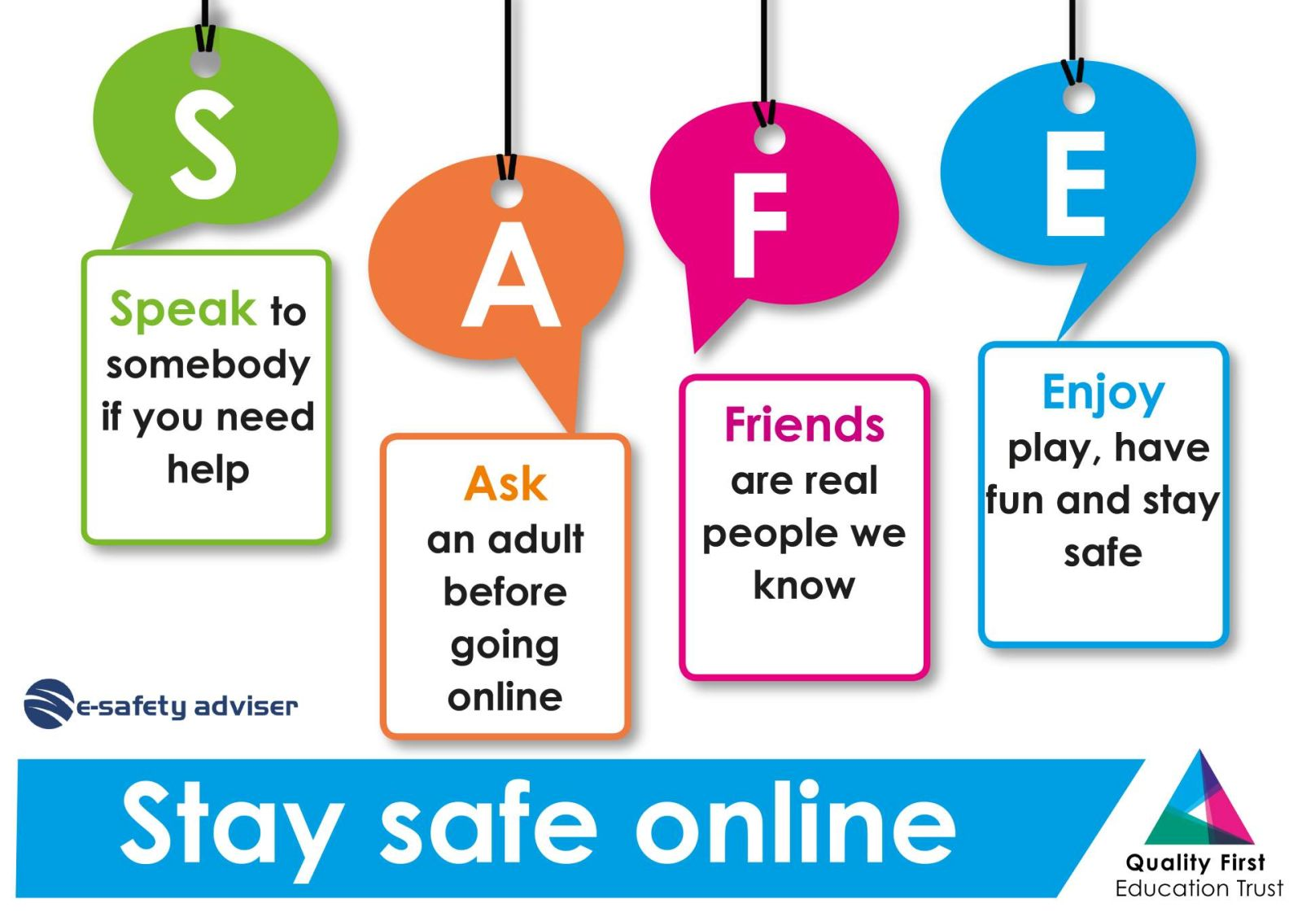

Geography

What is it like here?

In this topic, children will explore where they are in the world geographically.

They will begin to use and create aerial maps.



English

We will be following the Reception structure of ‘Drawing Club’ to support children’s independent writing.   
We will focus on the Year 1 skill of capital letters and full stops.

PE

ABC – Agility, Balance and Coordination.

PSHE

Families and Relationships

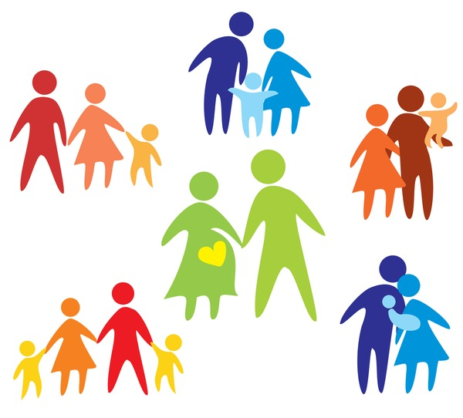

Design Technology

We will use different materials to construct a windmill

