Maths – Shape, statistics, position & direction

We will learn:

* Shape – identify angles, shapes and symmetry
* Statistics – interpret charts and line graphs
* Position and direction – coordinates and translations

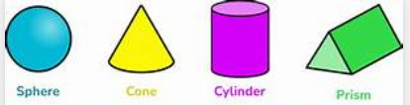 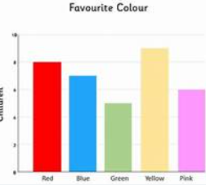 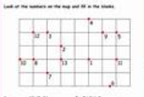

DT – digital world electronic charm

We will be learning:

* To evaluate electronic wearables.
* To design a light-up wearable.
* To program

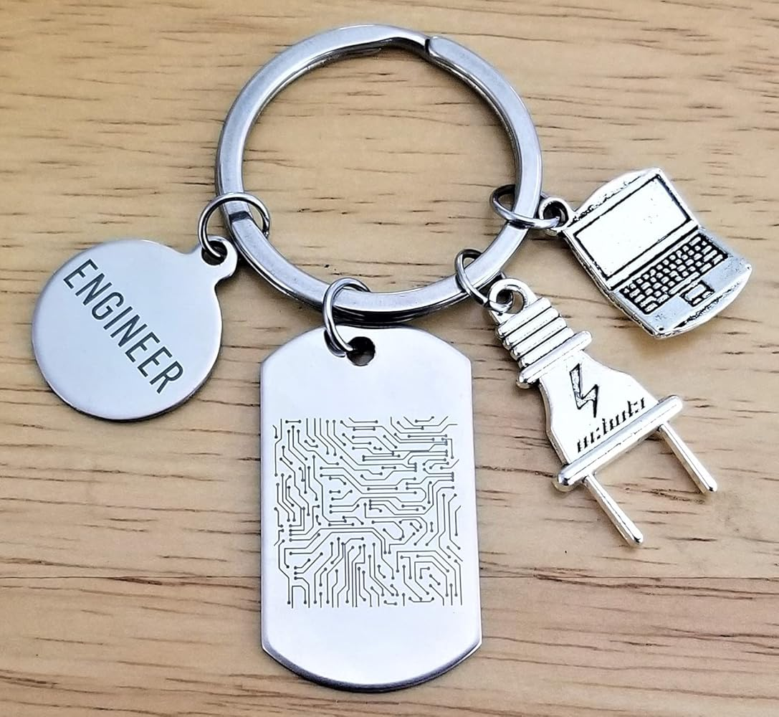.

Music – Adapting and transposing motifs

We will be learning:

* What a musical motif is
* To compose, notate, develop and transpose a musical motif
* To combine and perform motifs

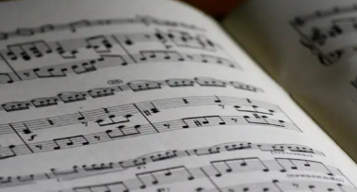

PSHE – Economic wellbeing

We will learn about:

* Spending and budgeting
* Money and emotions
* Jobs and careers



PE

This term we will be focusing on orienteering/field work and games for example cricket and rounders.

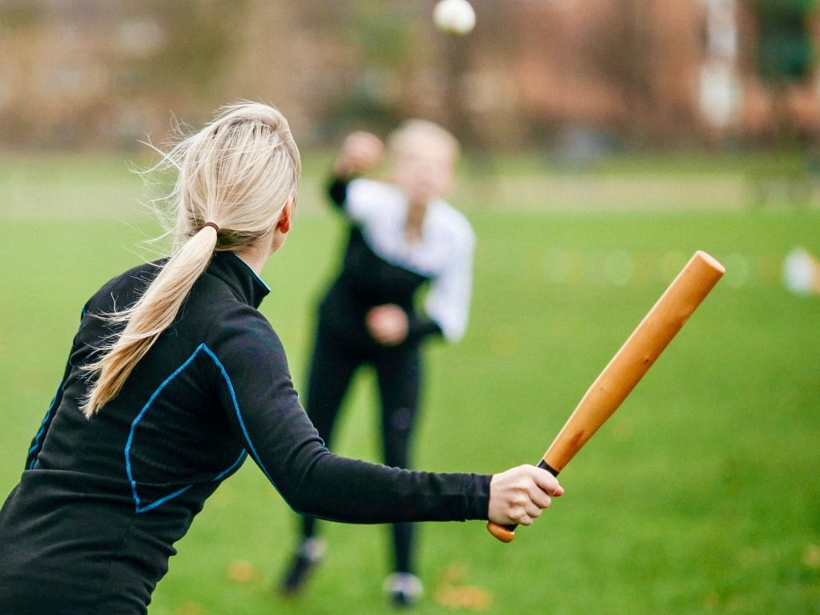

RE – How and why do people mark the significant events in life?

We will be learning about the beliefs of people from different worldviews surrounding commitment and promises.

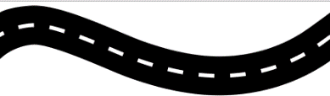

Computing – Creating media – Website design

We will learn how websites and webpages are created while developing our word processing and research skills. We will be plan and create our own website.

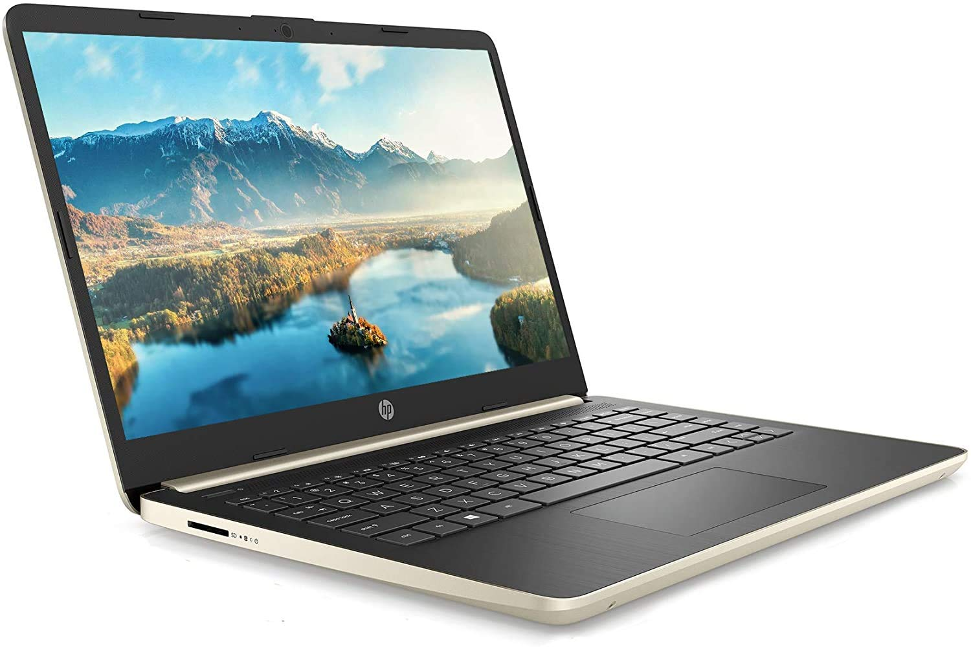

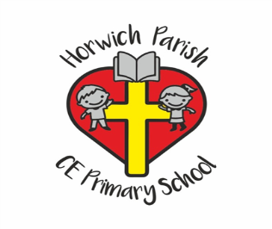

4B

Summer 2

Geography – What are rivers and how are they used?

We will learn:

* To describe the water cycle.
* To recognise the features of a river and how rivers are used.
* To name and locate some of the world’s rivers.

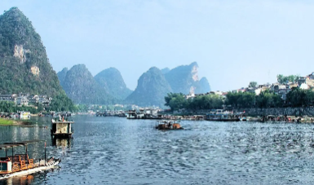

English

We are going to read the Shakespeare play ‘Julius Caesar’ and write a play script for part of the story.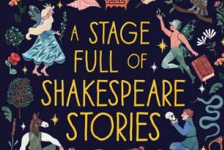

Science – Investigating liquids

We will learn to:

* Plan a comparative test
* Gather and record data
* Observe and problem solve

