Music

An introduction to playing keyboards 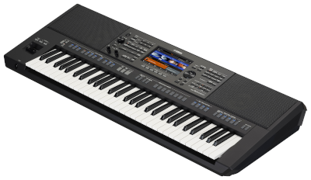

Maths

Ever heard of Fibonacci? We will be learning about his sequence and spirals. 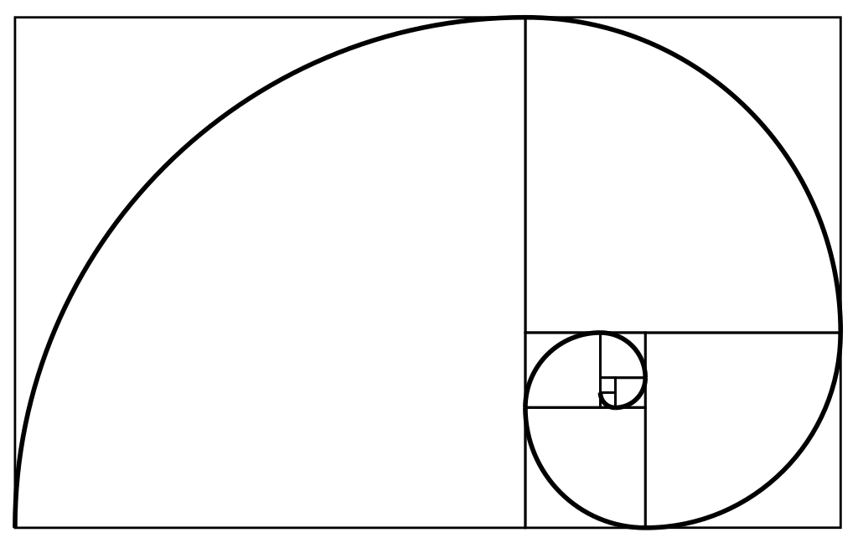

English

In our writing, we will be writing a narrative based on The Piano by Aidan Gibbons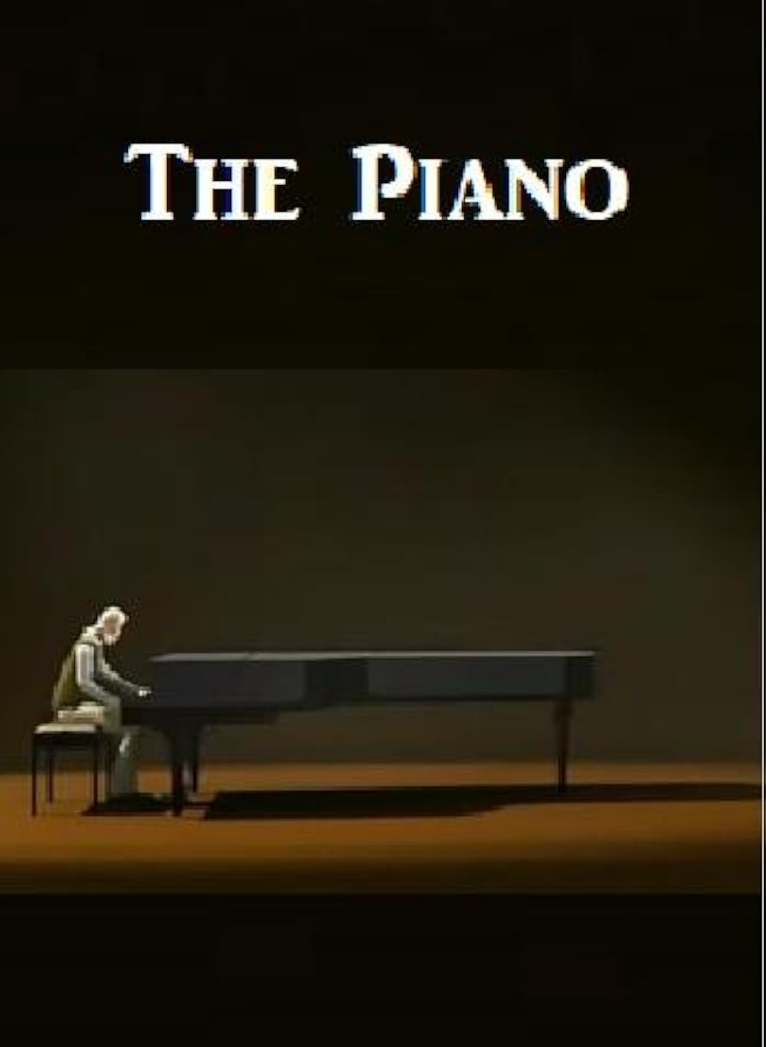

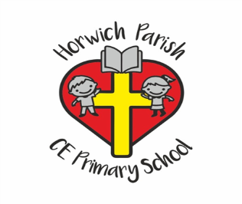

Year 6

Summer 2

PE

We will be working with Key PE

RE

What kind of king is Jesus?

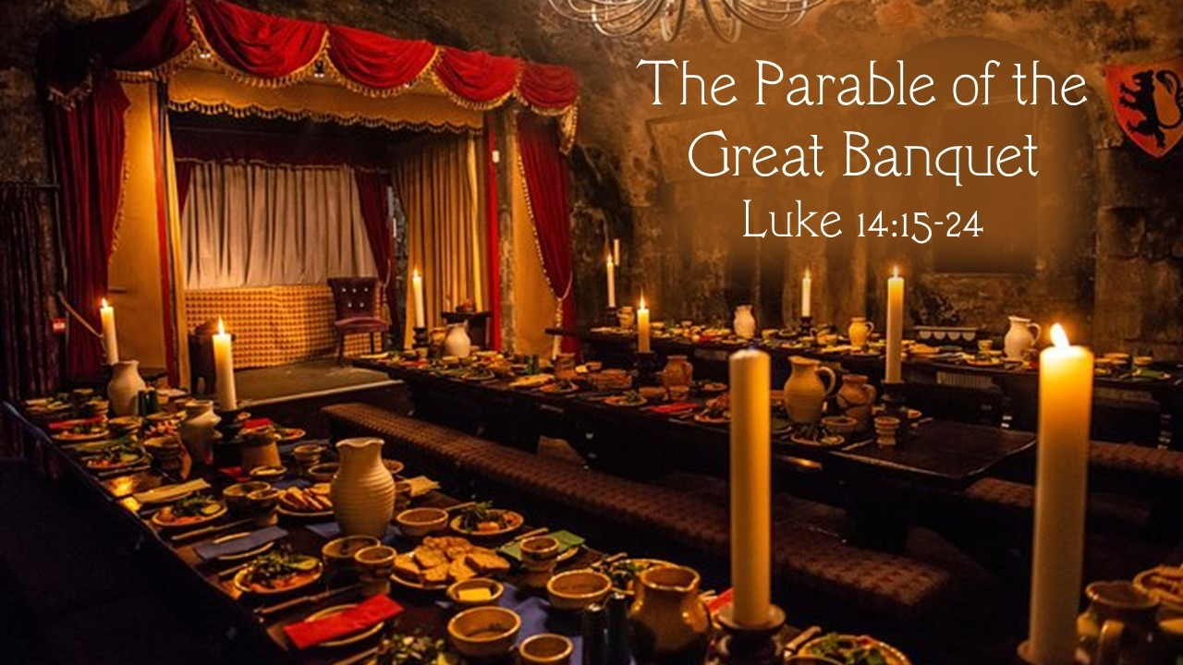

PSHE

Recognising the role of pressure groups and understanding diversity



The Arts

Musical Theatre –The Lion King

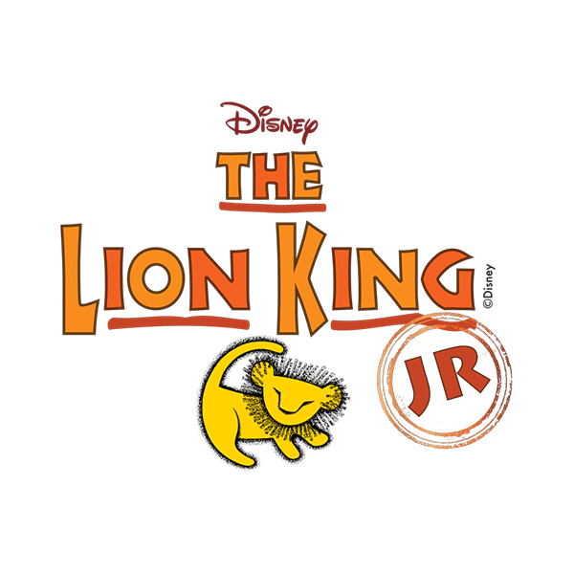

History

Who should go on the £10 banknote?

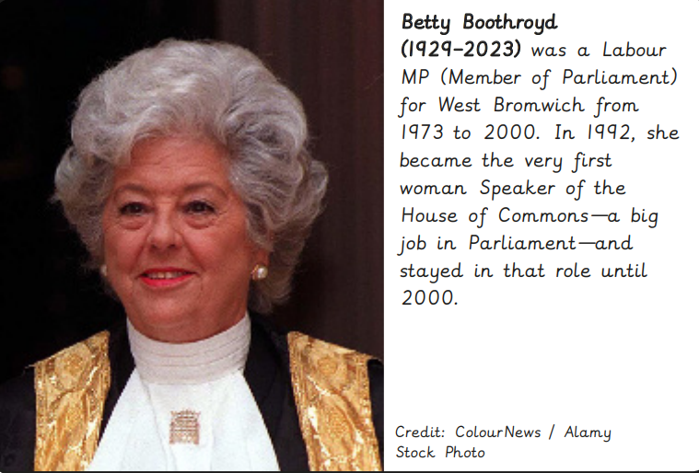

Science

Which characteristics are inherited and what is evolution?

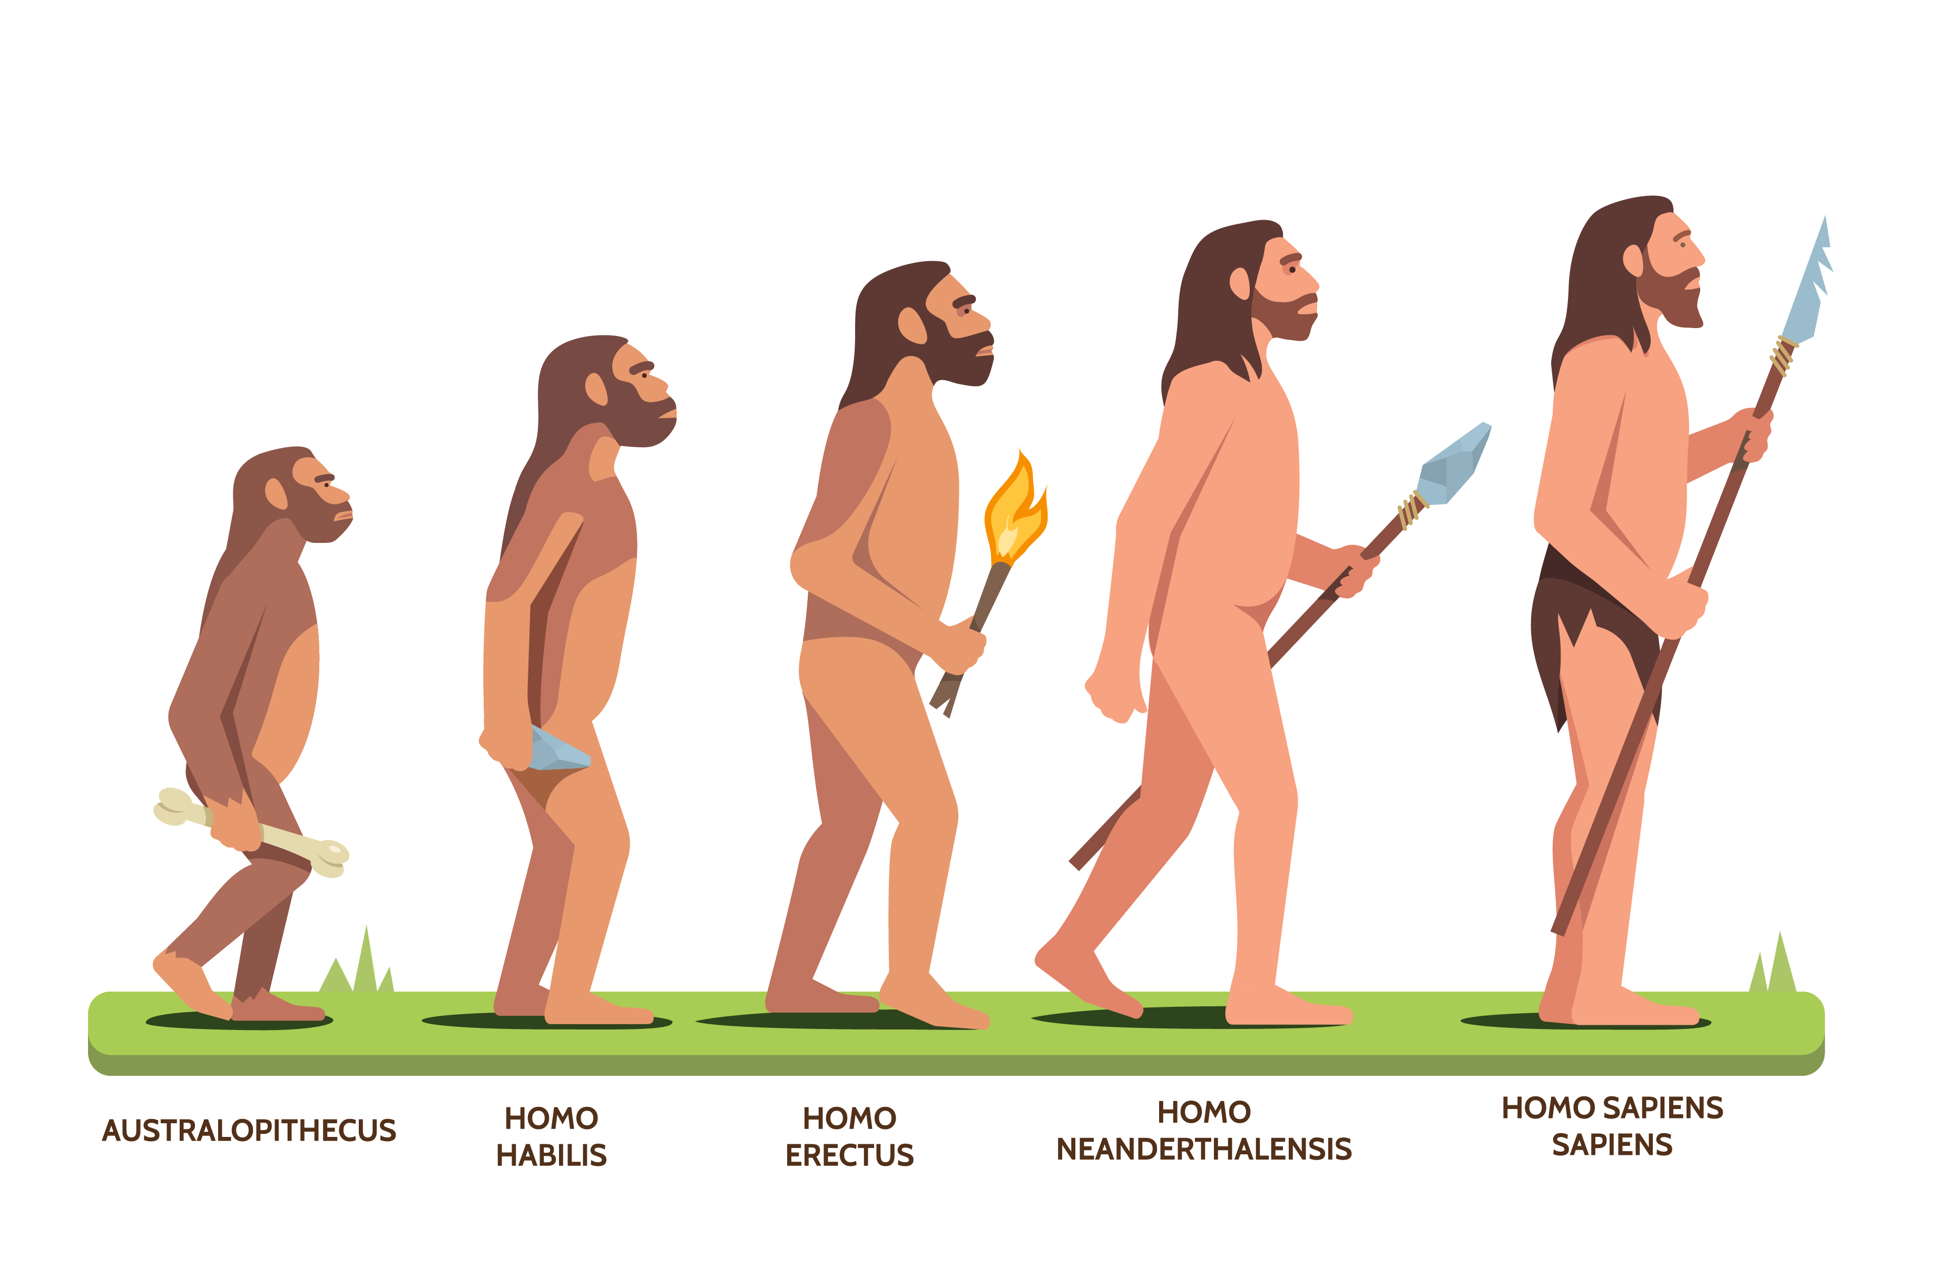

Computing

Creating Media – Website Design

