English

Our focus text will be: Goldilocks and Just the One Bear by Leigh Hodkinson.

We will be exploring traditional tales and refining our skills of using ‘and’ as a conjunction.

We will continue to develop our fundamental writing skills (capital letters and full stops).

RE

We will be focusing on gospel work with the key question: what makes some places sacred to believers?

In this unit we will exploring places of worship.

PSHE

We will be focusing on economic wellbeing including how to keep money safe, how to save and how we’d like to spend our money.

PE

We will be learning how to play tennis.

We will be building our wrist strength to keep a steady racquet hold.

We will be serving and returning balls.

History

We will be following the key question: ‘how did we learn ti fly?’

We will focus on the Wright brothers, Bessie Coleman, Amelia Earhart and the moon landing.

Maths

We will be focusing on fractions, position and direction, place value within 100, money and time.

Music

We will be learning about how to use our voice and body as instruments.

We will be exploring music with the theme ‘by the sea’.

Art

We will be learning how to use a pencil to create light and dark.

We will be creating still life drawings from a chosen perspective.

Computing

We will continue to develop our skills of programming and early coding.

Science

We will be focusing on plant based materials and making connections based on our learning in Spring 2.

We will be testing and creating our own plant pots.

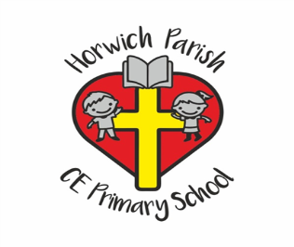

Year 1

Summer 2